**Banking Database System**

REVIEW REPORT

Submitted by

**Group Member1: Varun Chaudhary (20BCE2536)**

**Group Member2: Ananya Anand (19BCE2332)**

**Group Member3: Irene John (19BCE2437)**

Prepared For

**DATABASE MANAGEMENT SYSTEM (CSE2004)**

**PROJECT COMPONENT**

Submitted To

**Dr. Jyosimita Chaki**

**Associate Professor**

**School of Computer Science and Engineering**



Table of contents

**Chapter** **Page no**

**ABSTRACT** 3

**1. INTRODUCTION** 4

**1.1 Background** 5

**1.2 Objective** 5

**1.3 Motivation** 6

**1.4 Contributions of the Project** 6

**1.5 Organization of the Project** 7

**1.6 Work Breakdown** 8

**2. PROJECT RESOURCE REQUIREMENTS** 9

**2.1 Software Requirements** 9

**2.2 Hardware Requirements** 9

**3 LITERATURE SURVEY** 10

**4. DESIGN OF THE PROJECT** 11

**4.1 ER Diagram** 11

**4.2 ER to Relational Mapping (Schema Diagram)** 12

**4.3 Normalization** 13

**4.4 Tables and Constraints** 24

**5. IMPLEMENTATION** 28

**5.1 Introduction** 28

**5.2 DDL & DML Queries** 28

**5.3 SQL Queries** 30

**5.4 PL/SQL** 32

**6. SCREENSHOTS (FRONT END-WITH EXPLANATION)** 38

**6.1 Login screen** 38

**6.2 Savings Account creation** 44

**6.3 Transactions** 45

**Back-end: database view** 49

**7. CONCLUSION AND FUTURE WORK** 58

**7.1 Conclusion** 58

**7.2 Future Work** 58

**REFERENCES:** 59

# **ABSTRACT**

In the current world where every application finds a place in the online platform, Banking System would be one of them. A bank is a financial intermediary involving several functionalities such as safeguarding, transferring, exchanging, or lending of money. Understanding these fundamental functionalities helps one to understand how banking systems work and helps to build modern trends in banking and finance.

Keeping in mind the functionalities and the need of the present generation we have developed a database management system for bank accounts for all the customers enrolled in bank.It involves the database that the bank maintains for all customer functionality.It keeps the day by day tally record as a complete banking involving information of Account type, Deposit, Withdrawal and Searching the transaction. It removes the need of physical movement to a bank to carry out basic services offered at the bank.

This project involves various concepts of database and web development. Our website has a user friendly interface and it is being created using Xampp control Panel wherein MYSQL has been used for database management to store and retrieve data from the database. In addition we have created multiple pages linked to each other. These pages have been developed and designed using HTML and CSS. PhP is used as a tool for connectivity between the front-end and the back-end. Indeed, this has been a great learning experience especially for the concepts of database and its practical application.

# **1. INTRODUCTION**

During the past several decades’ personnel function has been transformed from a relatively obscure record keeping staff too central and top level management function. There are many factors that have influenced this transformation like technological advances, professionalism, and general recognition of human beings as most important resources.

A computer based management system is designed to handle all the primary information required to calculate monthly statements of customer account which include monthly statement of any month. Separate database is maintained to handle all the details required for the correct statement calculation and generation.

This project intends to introduce more user friendliness in the various activities such as record updating, maintenance, and searching. The searching of record has been made quite simple as all the details of the customer can be obtained by simply keying in the identification or account number of that customer. Similarly, record maintenance and updating can also be accomplished by using the account number with all the details being automatically generated. These details are also being promptly automatically updated in the master file thus keeping the record absolutely up-to-date.

The entire information has maintained in the database or Files and whoever wants to retrieve can’t retrieve, only authorization user can retrieve the necessary information which can be easily be accessible from the file.

## **1.1 Background**

In this section of our project we will like to mention background or the prerequisites skills that we need to have in order to carry out this project. The main area of knowledge in this project is the creation of databases. Thorough knowledge of ER diagram, functional dependencies, normalization etc. For the completion of the project we should have knowledge of the subjects listed –

1. HTML, CSS and PHP for front end development,
2. MYSQL in XAMMP SERVER for backend,
3. SQL for preparing the database.

## **1.2 Objective**

The main objective of the project is to develop online Banking system for banks. In present system all banking works is done manually. User have to visit bank for Withdrawal or Deposit amount. In present bank system it is also difficult to find account information of account holder. In this bank management system we will automate all the banking process. In our bank management system user can check his balance online and he can also transfer money to other account online. In this software you can keep record for daily Banking transactions. The main purpose of developing bank management system is to design an application, which could store bank data and provide an interface for retrieving customer related details.

## **1.3 Motivation**

Our major motivation of carrying out this project is that amidst the ongoing digital banking environment, the need for an efficient banking management solution is strongly felt. These systems are crucial for the growth of any sector and provide a multidisciplinary approach to the management as well as the governance of the bank related activities. These systems make the best use of computer systems as well as software for helping the bank and customer to create new account easily. The project makes a sincere effort to provide all the mentioned features to meet the requirements of the bank in terms of both the employees and the customer. Also, another source of motivation is Scams which our going on in the market. Thus, such factors piqued our interests to work on such project.

## **1.4 Contributions of the Project**

Using this bank management system any information can be easily searched. User can view all the details of the customer, user can create new customer account and maintain its data efficiently and effectively. Which are maintained constantly update by system. Manage large number of customer details with ease. Particular account information can be modified particular customer record can be modified for one or more field’s customer name, address by providing account number. Activities like updating, modification, deletion of records should be easier. A customer record can be easily deleted by authorize user by providing account number.

## **1.5 Organization of the Project**

* First, we started off with preparation of ER diagram taking into view all the possible attributes and relationships among them.
* Next, we converted our ER diagram to Relational mapping so that we can get an actual picture of all the relationships.
* After carrying out above mentioned steps we made list of all the tables and constraints of attributes.
* Next, we collected sample data to be stored in our database.
* After that we started with preparation of database in MYSQL with our collected data.
* After creation of initial Database, we normalized our tables so that inconsistency of our database can be reduced.
* After successful creation of our Final Database we operated few normal SQL queries and PL/SQL queries.
* After that we constructed our website and prepared its Front End and Back End and connected the Front end to our database.

## **1.6 Work Breakdown**

|  |  |  |
| --- | --- | --- |
| **Registration Number** | **Team Member-Name** | **Work Assigned** |
| 20BCE2536 | Varun Chaudhary | -Entire front-end implementation of the project and backend coding  -Compilation of the project  (connection between back-end and front-end using php ) |
| 19BCE2332 | Ananya Anand | Database implementation  (database relations creation)  -Documentation |
| 19BCE2437 | Irene John | Database implementation  (data collection and application of constraints)  -Documentation |

# **2. PROJECT RESOURCE REQUIREMENTS**

## **2.1 Software Requirements**

Front- End Software Used:

* PHP
* HTML
* CSS (materialize style sheet)

Back- End Software Used:

* MYSQL in XAMMP SERVER

Text Editor to type php files: SUBLIME TEXT

## **2.2 Hardware Requirements**

Processor- Intel i3 OR ABOVE

Clock speed- 2.5 GHz

Ram 8 GB or above

Windows 10 or any other suitable OS

# **3 LITERATURE SURVEY**

In this section, literature survey is given. Accordingly, research papers are reviewed and analyzed based on the prediction methods used.

|  |  |  |  |  |
| --- | --- | --- | --- | --- |
| **Authors** | **Method** | **Purpose** | **Advantages** | **Disadvantages** |
| Momenul Ahmad | How to do web development | Giving general idea about web development and internet | It provides essential knowledge to beginner. | Knowledge provided is limited and it is not helpful to a more experienced developer. |
| Alijetro Castillo | Quantitative analysis on database contents | Provides knowledge about database contents and contains vast range of examples to analyze contents of database | It is vast and contains wide range of examples | It requires a pre requisite knowledge and not recommended for beginners |
| Me Me Khaing | 1.1.1.3 Why undergraduates should learn web development | Provides us with basic knowledge of HTML and CSS with some examples related to it | Provides HTML syntax and some examples regarding the same | It is nice document but it lacks some or the other syntax and contains less examples |
| Raghu Ramakrishnan | Introduction to DBMS | It is a textbook which helped us to understand ER diagram and conversion of it to relational mapping | Contains a nice overview of database | It would be better if it contains more examples and was better organized |
| Kavya .S | 1.1.1.1 A study on Database | Gives an overview on databases | Explains the general fundamentals and functioning | Lacks practical examples for reference |

# **4. DESIGN OF THE PROJECT**

**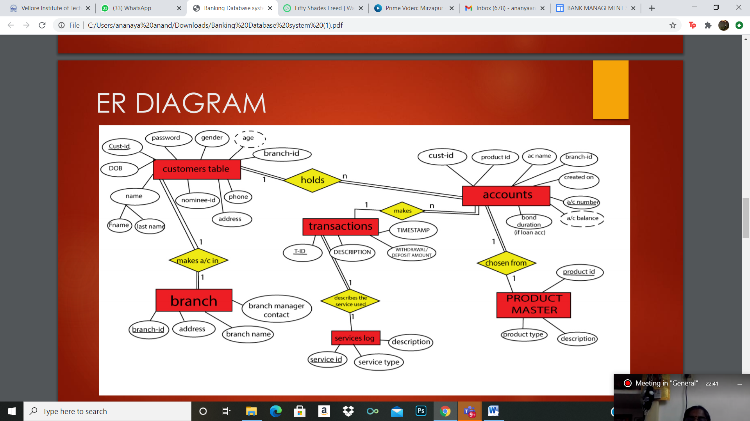****4.1 ER Diagram**

**KEY:**

**Entities**

Entities:

Relationships between Entities: Partial relation

Total relation

Relation

Relation

Structural Constraints:

Cardinality ratios: 1:1- One to one

1: N – One to Many

N: 1 – Many to one

N: N- Many to many

## **4.2 ER to Relational Mapping (Schema Diagram)**

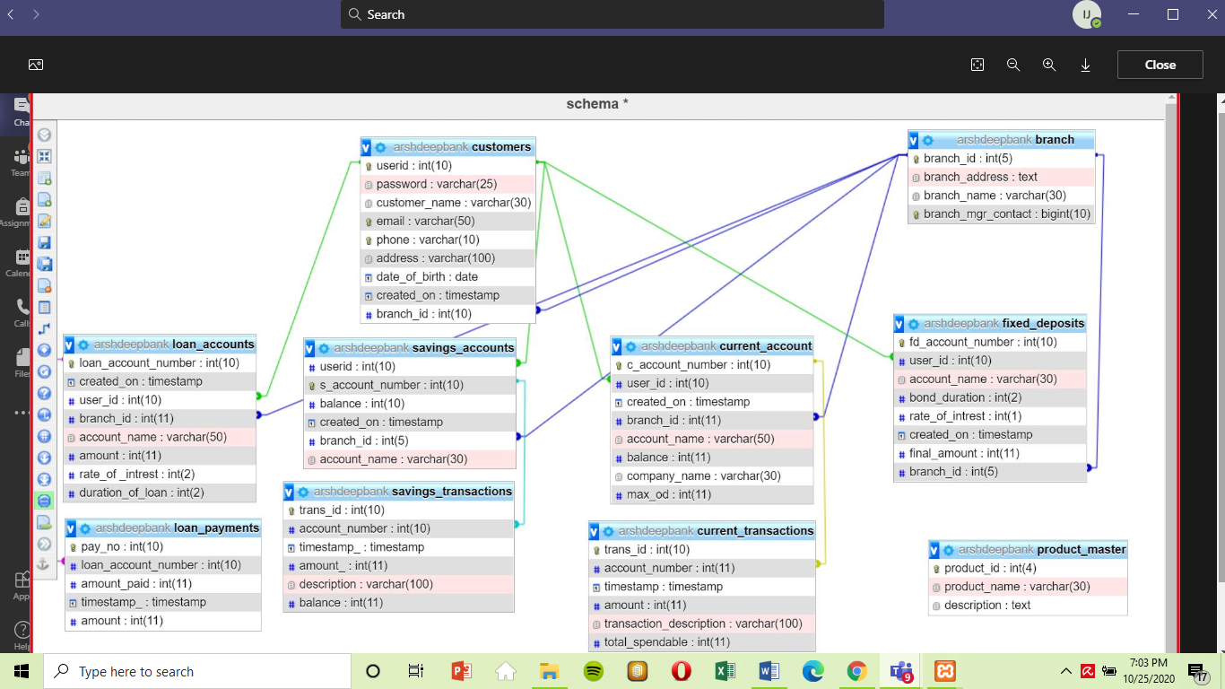

**KEY:**

Is the foreign key on user_id

Is the foreign key on branch_id

Is the foreign key on loan_acc_no

Is the foreign key on savings_acc_no

Is the foreign key on current_acc_no

## **4.3 Normalization**

**Rules for Normalization:**

**1NF (FIRST NORMAL FORM)**

• Each table cell should contain a single value.

• Each record needs to be unique.

**2NF (SECOND NORMAL FORM)**

• Rule 1- Be in 1NF

• Rule 2- There should be no partial dependency.

**3NF (THIRD NORMAL FORM)**

• Rule 1- Be in 2NF

• Rule 2- There should be no transitive functional dependencies.

**BCNF**

• Even when a database is in 3rd Normal Form, still there would be anomalies resulted if it has more than one Candidate Key.

• Sometimes is BCNF is also referred as 3.5 Normal Form.

**-Normalization of the Tables**

**1) Customers**

[User_id, Password,Name,email_id,phone,address,DOB.created_on,Gender]

**Functional dependencies:**

User_id-> Password User_id-> created_on

User_id->Name User_id->Gender

User_id-> address User_id->phone

User_id->DOB User_id->email_id

**Candidate Ke**y: User_id

**1NF:** It is in 1NF due to atomicity

**2NF:** It is in 2NF as it is in 1NF and there are no partial dependencies

**3NF:** It is in 3 NF as it is in 2NF and there are no transitive dependencies

**BCNF:** It is in BCNF as it is in 3NF and the LHS of the F.d's is a prime key

Since the table is already normalized, the table Customers remains the same.



**2) Branch**

[br_id,br_name,address,mgr_contact]

**Functional dependencies:**

br_Id->address br_Id-> br_name

br_Id->mgr_contact

**Candidate Key:** br_Id

**1NF:** It is in 1NF due to atomicity

**2NF:** It is in 2NF as it is in 1NF and there are no partial dependencies

**3NF:** It is in 3 NF as it is in 2NF and there are no transitive dependencies

**BCNF:** It is in BCNF as it is in 3NF and the LHS of the F.d's is a prime key

Since the table is already normalized, the table Branch remains the same.



**3) Product master**

[product_id,acc_type,ac_info]

**Functional dependencies:**

product_Id->acc_type,ac_info

**Candidate Key:** product_Id

**1NF:** It is in 1NF due to atomicity

**2NF:** It is in 2NF as it is in 1NF and there are no partial dependencies

**3NF:** It is in 3 NF as it is in 2NF and there are no transitive dependencies

**BCNF:** It is in BCNF as it is in 3NF and the LHS of the F.d's is a prime key

Since the table is already normalized, the table Product Master remains the same.



**Accounts**

The accounts table in the initial database was inconsistent as all account types were clubbed together with many null able domains.

Ex: If account number 1000010 has a savings account the values like bond duration or rate of interest which concerns with loan type will be null able

Thus accounts table has been parted into  
-Savings account

-Current

-Loan

-Fixed Deposit

Normalizing Accounts table





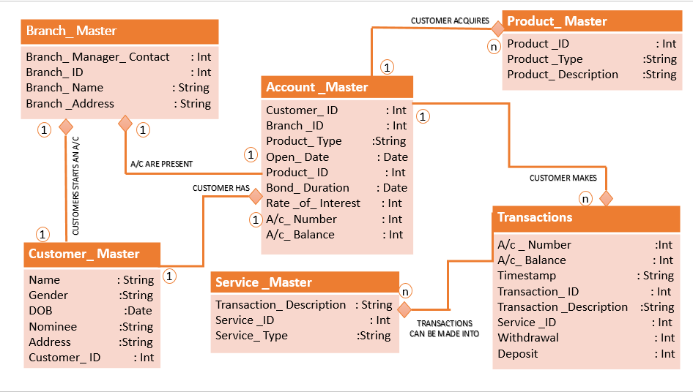





**4) Savings Account**

[Acc_id,cust_id,creationtimestamp,branch_id,Acc_name,balance]

**Functional dependencies:**

Acc_Id-> cust_id Acc_Id-> branch_id

Acc_Id-> created_timestamp Acc_Id->Acc_name

Acc_Id-> balance

**Candidate Key:** Acc_Id

**1NF:** It is in 1NF due to atomicity

**2NF:** It is in 2NF as it is in 1NF and there are no partial dependencies

**3NF:** It is in 3 NF as it is in 2NF and there are no transitive dependencies

**BCNF:** It is in BCNF as it is in 3NF and the LHS of the F.d's is a prime key

Hence the table is normalized.

**5) Current Account**

[Acc_id,cust_id,creationtimestamp,branch_id,Acc_name,balance,company_name,max_d]

**Functional dependencies:**

Acc_Id-> cust_id Acc_Id-> branch_id

Acc_Id-> created_timestamp Acc_Id->Acc_name

Acc_Id-> balance Acc_Id-> max od_amt

Acc_Id-> company name

**Candidate Key:** Acc_Id

**1NF:** It is in 1NF due to atomicity

**2NF:** It is in 2NF as it is in 1NF and there are no partial dependencies

**3NF:** It is in 3 NF as it is in 2NF and there are no transitive dependencies

**BCNF:** It is in BCNF as it is in 3NF and the LHS of the F.d's is a prime key

Hence the table is normalized.

**6) Loan**

[Ln_no,cust_id,created_timestamp,branch_id,Acc_name,rate_of_interest,duration,amount]

**Functional dependencies:**

Ln_no-> cust_id Ln_no-> branch_id

Ln_no-> created_timestamp Ln_no ->Acc_name

Ln_no-> duration Ln_no ->rate_of_interest

**Candidate Key:** Ln_no

**1NF:** It is in 1NF due to atomicity

**2NF:** It is in 2NF as it is in 1NF and there are no partial dependencies

**3NF:** It is in 3 NF as it is in 2NF and there are no transitive dependencies

**BCNF:** It is in BCNF as it is in 3NF and the LHS of the F.d's is a prime key

Hence the table is normalized.

**7) Fixed Deposit**

[Acc_id,cust_id,name,duration,rate_of_interest,created_on,final_amount,Acc_name]

**Functional dependencies:**

Acc_Id-> cust_id Acc_Id->duration

Acc_Id-> created_on Acc_Id->Acc_name

Acc_Id-> rate_of_interest Acc_Id->final_amount

**Candidate Key:** Acc_Id

**1NF:** It is in 1NF due to atomicity

**2NF:** It is in 2NF as it is in 1NF and there are no partial dependencies

**3NF:** It is in 3 NF as it is in 2NF and there are no transitive dependencies

**BCNF:** It is in BCNF as it is in 3NF and the LHS of the F.d's is a prime key

Hence the table is normalized.

**Transactions**

Just like the accounts table the transaction table was clubbed under one table which leads to inconsistencies and abnormalities. Hence breaking the tables into:

-Savings Transactions

-Current Transactions

-Loan payments

****Normalizing Transactions table







**8) Savings_transactions**

[TID,Acc_id,Timestamp,amount,description,balance]

**Functional dependencies:**

TID-> Acc_id TID->amount

TID-> Timestamp TID-> balance

TID-> description

**Candidate Key:** TID

**1NF:** It is in 1NF due to atomicity

**2NF:** It is in 2NF as it is in 1NF and there are no partial dependencies

**3NF:** It is in 3 NF as it is in 2NF and there are no transitive dependencies

**BCNF:** It is in BCNF as it is in 3NF and the LHS of the F.d's is a prime key

Hence the table is normalized.

**9) Current_transaction**

[TID,Acc_id,Timestamp,amount,description,Total]

**Functional dependencies:**

TID-> Acc_id TID->amount

TID-> Timestamp TID-> Total

TID-> description

**Candidate Key:** TID

**1NF:** It is in 1NF due to atomicity

**2NF:** It is in 2NF as it is in 1NF and there are no partial dependencies

**3NF:** It is in 3 NF as it is in 2NF and there are no transitive dependencies

**BCNF:** It is in BCNF as it is in 3NF and the LHS of the F.d's is a prime key

Hence the table is normalized.

**10) Loan_Payments**

[Pay_no,Ln_no,amt_paid,date_timestamp,remaining_due]

**Functional dependencies:**

Pay_no->ln_no Ln_no-> amt_paid

Pay_no-> date_timestamp Ln_no->remaining_due

**Candidate Key:** Pay_no

**1NF:** It is in 1NF due to atomicity

**2NF:** It is in 2NF as it is in 1NF and there are no partial dependencies

**3NF:** It is in 3 NF as it is in 2NF and there are no transitive dependencies

**BCNF:** It is in BCNF as it is in 3NF and the LHS of the F.d's is a prime key

Hence the table is normalized.

## **4.4 Tables and Constraints**

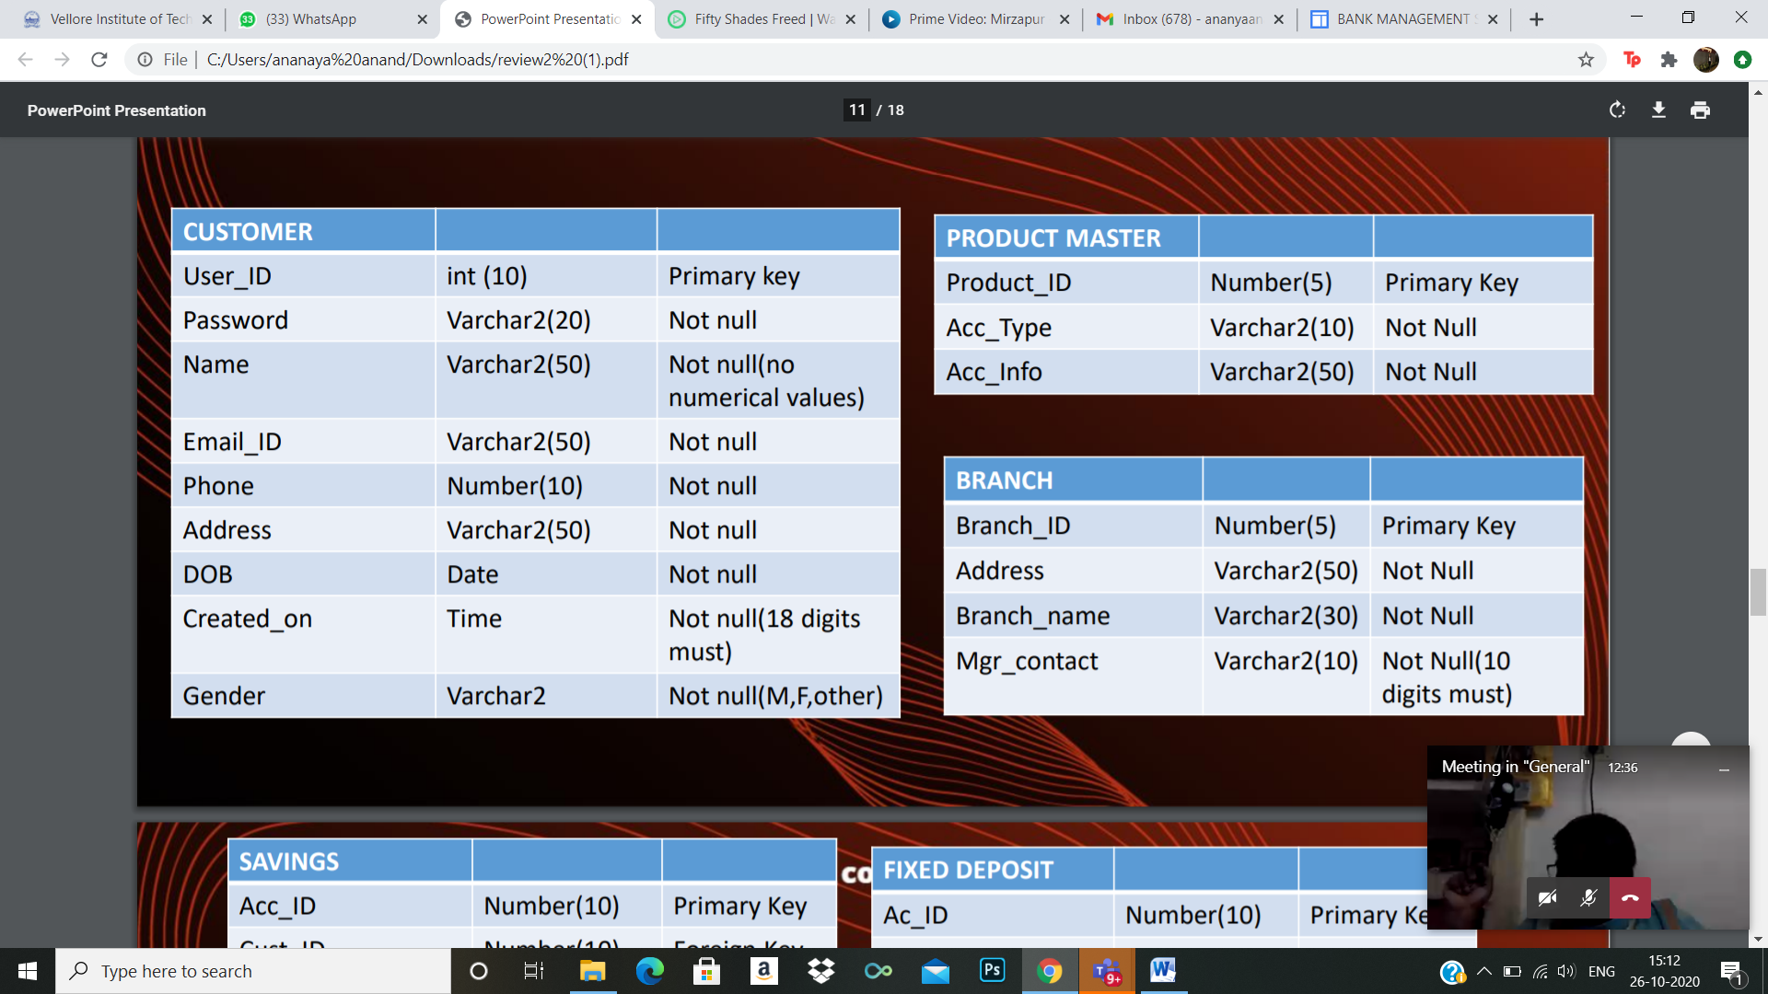TABLE : CUSTOMER

TABLE: PRODUCT MASTER

TABLE: BRANCH

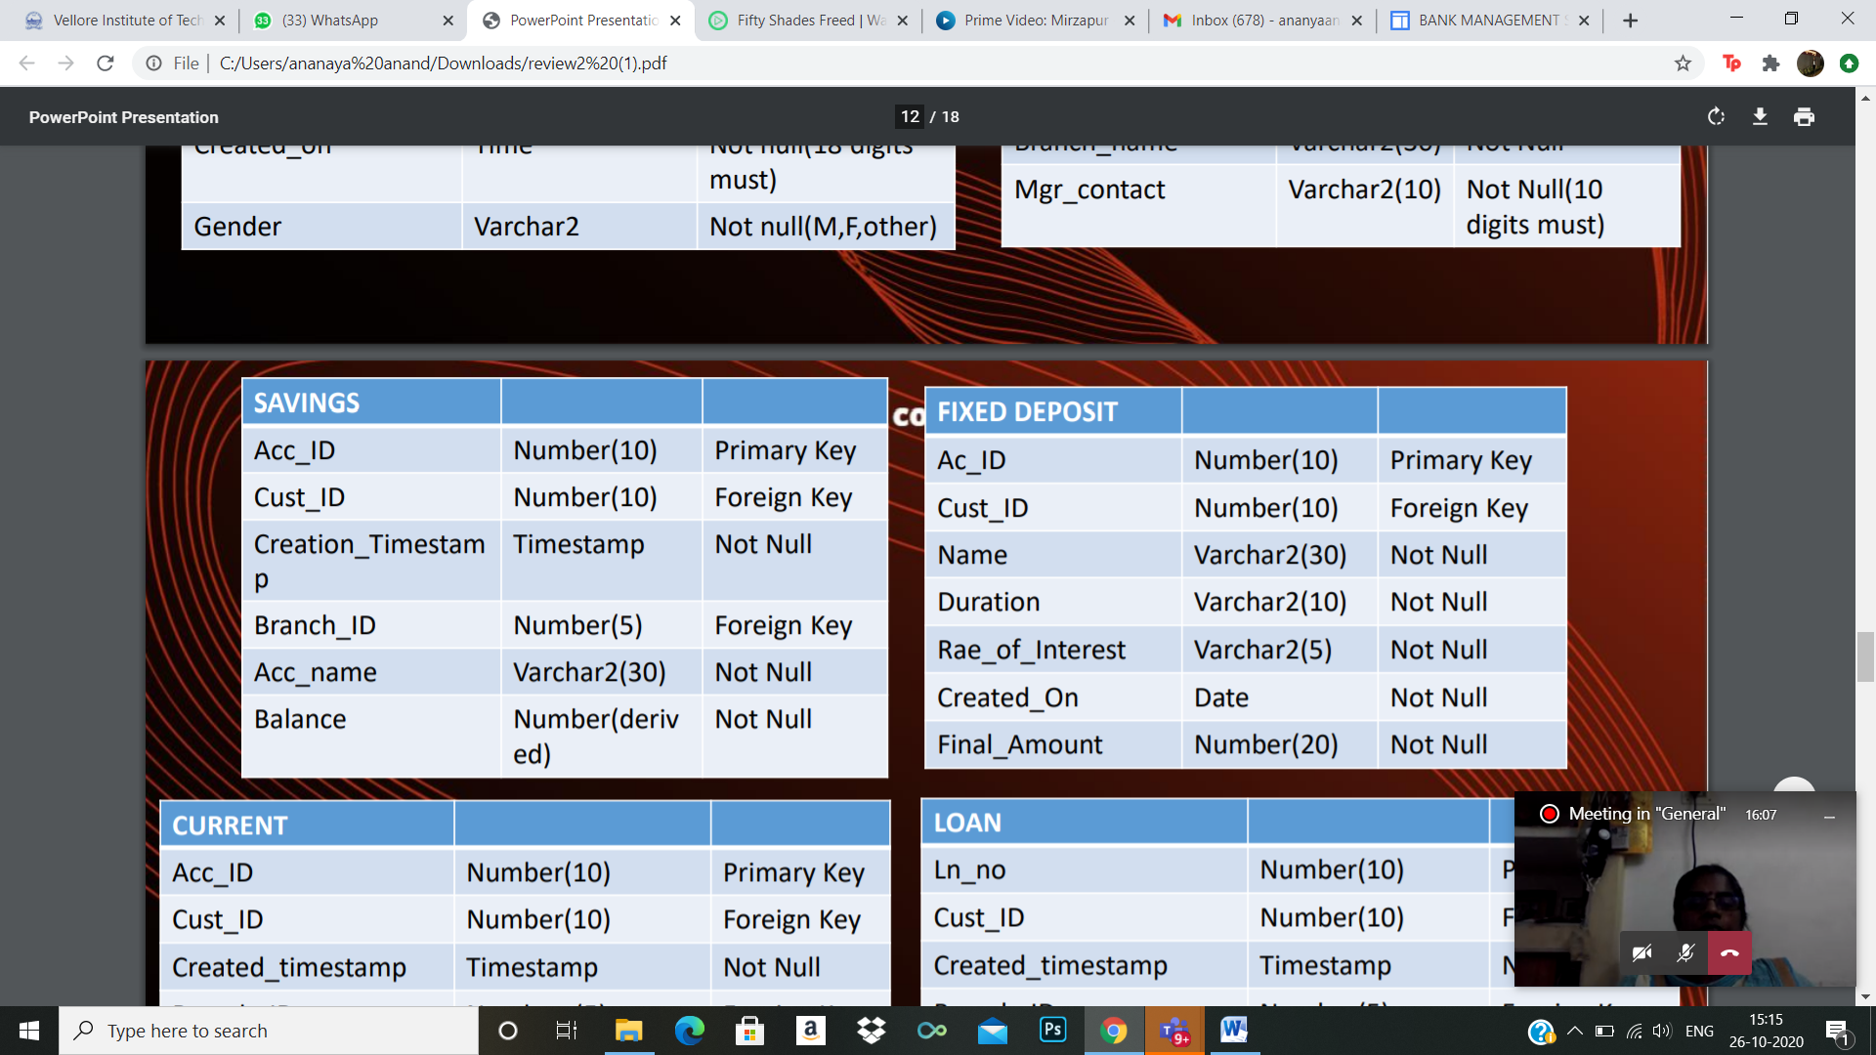TABLE: SAVINGS

TABLE: FIXED DEPOSIT

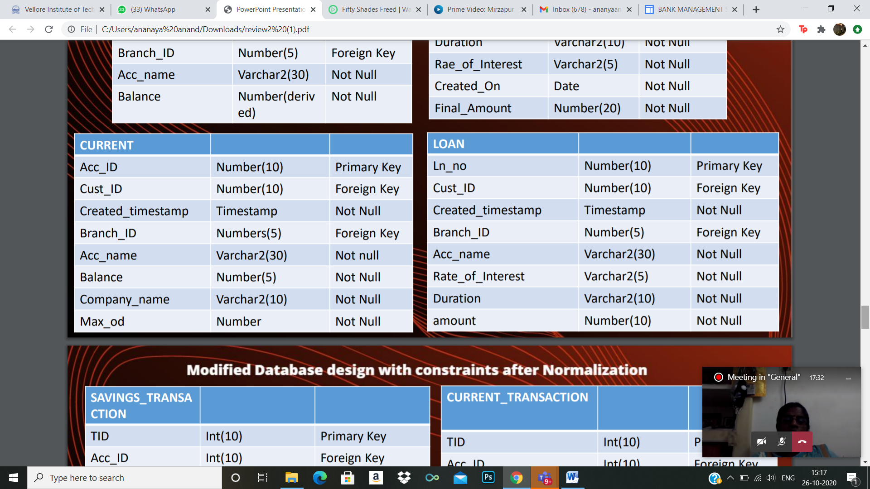 TABLE: LOAN

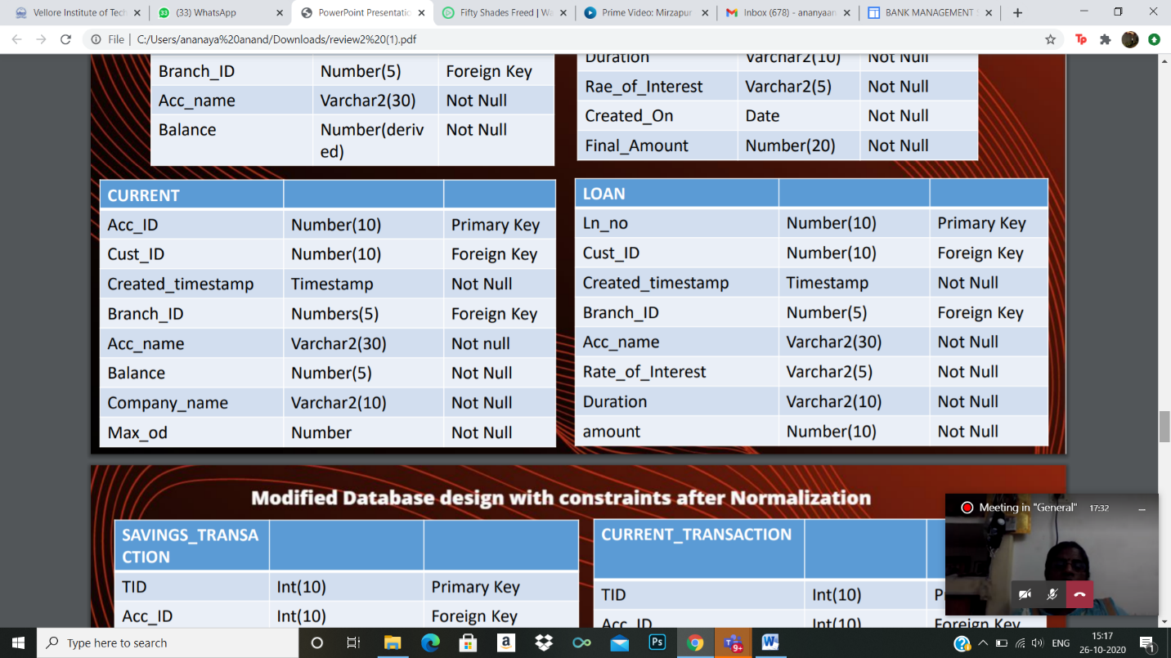 TABLE: CURRENT

TABLE: SAVINGS TRANSACTION

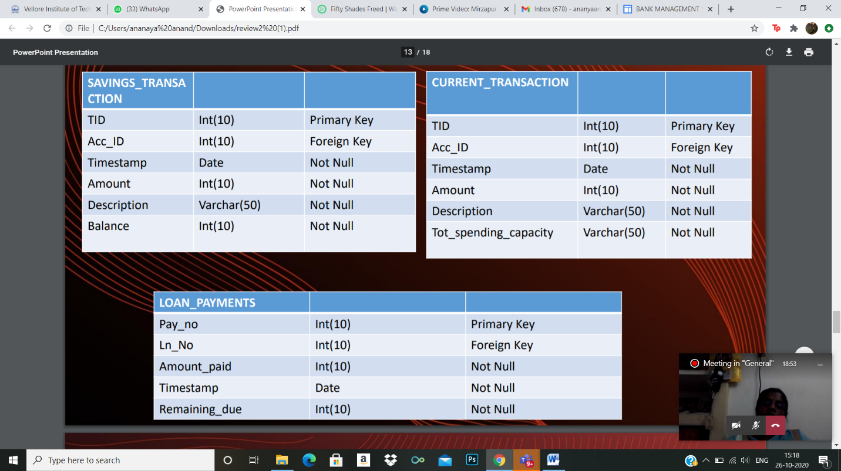

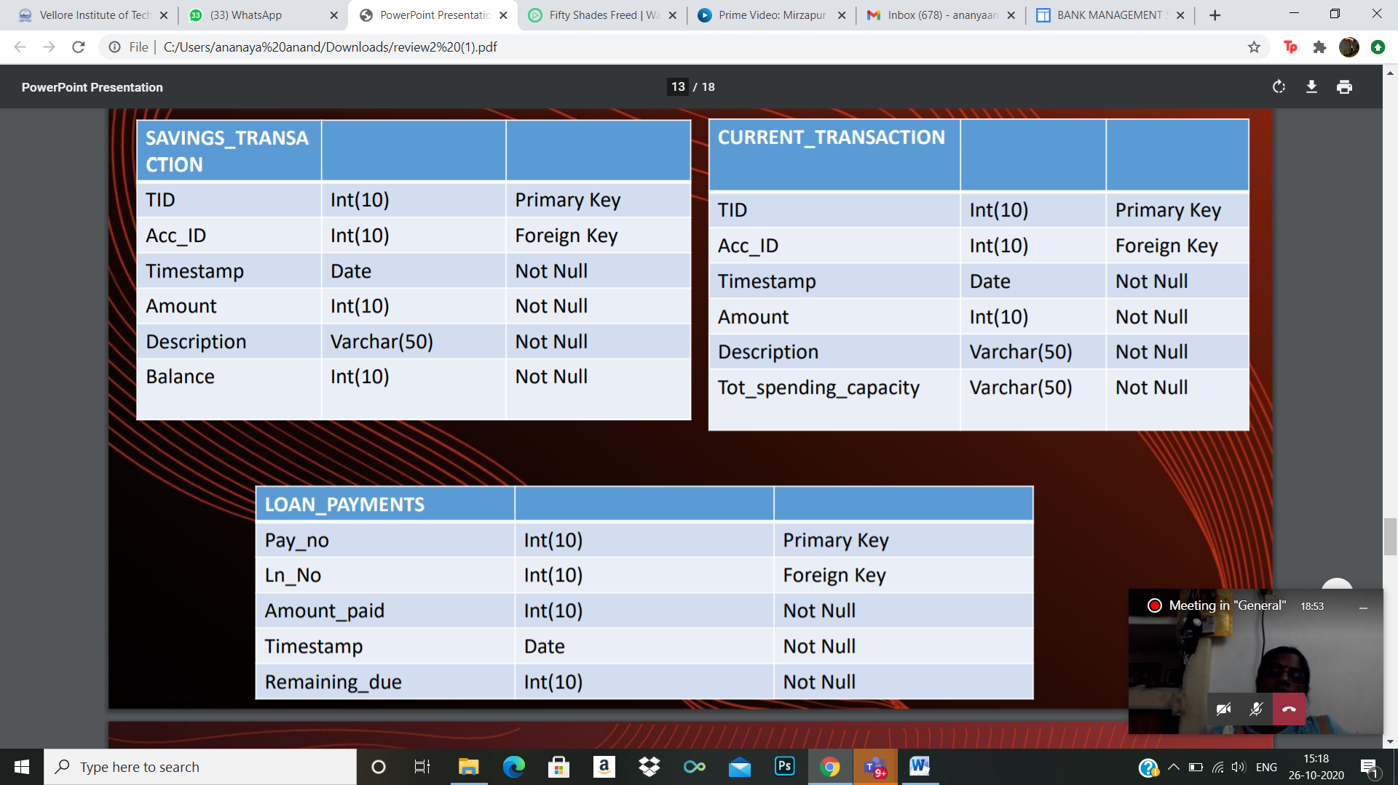TABLE: CURRENT TRANSACTION

TABLE: LOAN PAYMENTS

# **5. IMPLEMENTATION**

## **5.1 Introduction**

A simple user can access their account and can deposit/withdraw money from their account.

User can also transfer money from their account to any other bank account. User can see their

transaction report and balance enquiry too.

## **5.2 DDL & DML Queries**

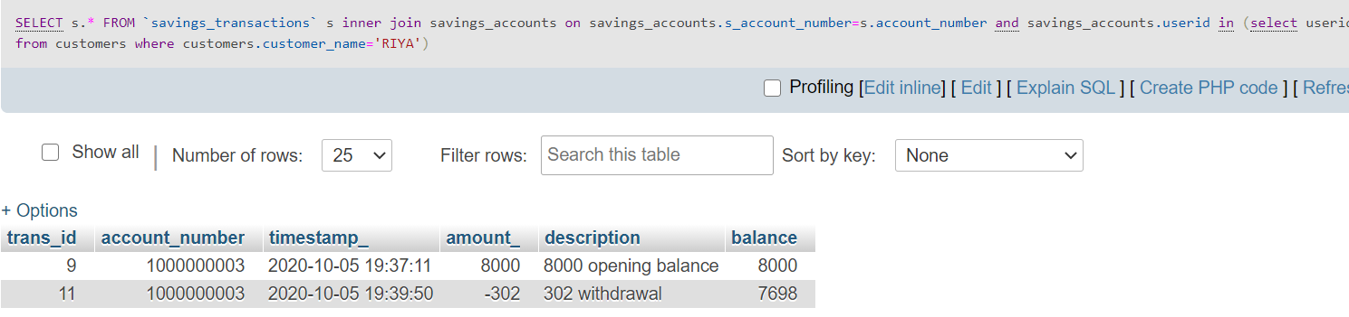1) Select all transactions on saving accounts owned by RIYA (use of inner join to join transactions accounts and customer table)

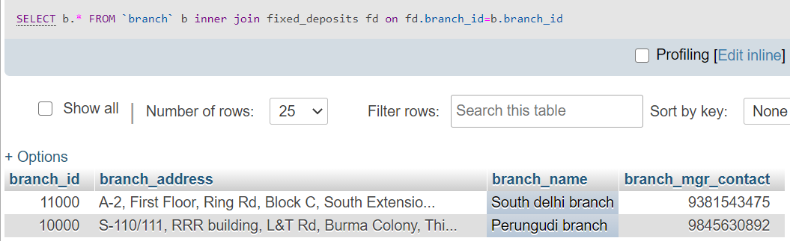2) Display branch information for all fixed deposit accounts (use of inner join on branch and fixed deposits table)

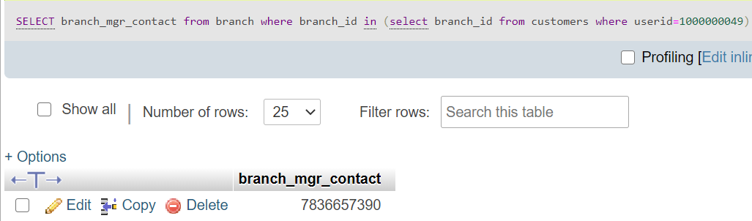3) Select the branch manager contact for each user. (Use of nested sub-queries)

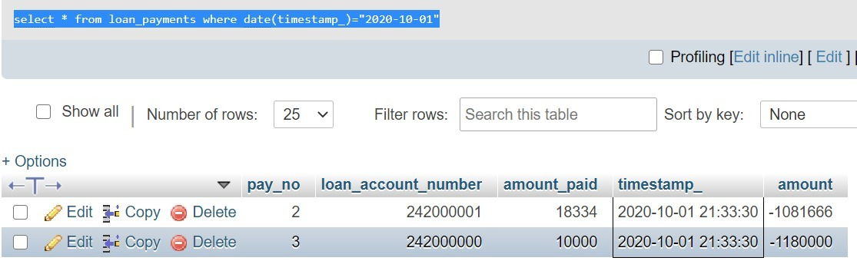4) Select all loan payments on 2020-10-01(use of date function to convert timestamp to date format.)  
select * from loan_payments where date(timestamp)=“2020-10-01

5) Select all branch information and customer information for a user =1000000049 using join.

[select](http://localhost/phpmyadmin/url.php?url=https://dev.mysql.com/doc/refman/5.5/en/select.html)  * from branch inner join customers on customers.branch_id=branch.branch_id [and](http://localhost/phpmyadmin/url.php?url=https://dev.mysql.com/doc/refman/5.5/en/logical-operators.html) customers.userid=1000000049

## **5.3 SQL Queries**

1)[SELECT](http://localhost/phpmyadmin/url.php?url=https://dev.mysql.com/doc/refman/5.5/en/select.html) * FROM customers inner join savings_accounts oncustomers.userid=savings_accounts.userid [and](http://localhost/phpmyadmin/url.php?url=https://dev.mysql.com/doc/refman/5.5/en/logical-operators.html) savings_accounts.balance<=6000 (inner join to select all information on joining customers and savings acc with balance <=6000)

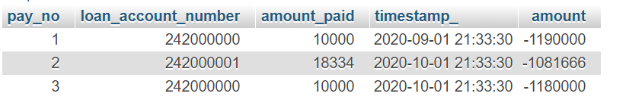2)[select](http://localhost/phpmyadmin/url.php?url=https://dev.mysql.com/doc/refman/5.5/en/select.html) loan_payments.* from loan_payments inner join loan_accounts on loan_payments.loan_account_number=loan_accounts.loan_account_number [and](http://localhost/phpmyadmin/url.php?url=https://dev.mysql.com/doc/refman/5.5/en/logical-operators.html) loan_accounts.branch_id [in](http://localhost/phpmyadmin/url.php?url=https://dev.mysql.com/doc/refman/5.5/en/comparison-operators.html) ([select](http://localhost/phpmyadmin/url.php?url=https://dev.mysql.com/doc/refman/5.5/en/select.html) branch_id from branch where branch_mgr_contact=9381543475)  
  
--use of join and sub query)

3) Combined use of sub query and date function

[SELECT](http://localhost/phpmyadmin/url.php?url=https://dev.mysql.com/doc/refman/5.5/en/select.html) * FROM current_account WHERE user_id [in](http://localhost/phpmyadmin/url.php?url=https://dev.mysql.com/doc/refman/5.5/en/comparison-operators.html) ([select](http://localhost/phpmyadmin/url.php?url=https://dev.mysql.com/doc/refman/5.5/en/select.html) userid from custo-mers where [year](http://localhost/phpmyadmin/url.php?url=https://dev.mysql.com/doc/refman/5.5/en/date-and-time-types.html) (customers.date_of_birth) = 1999)

4) Illustration of right join on current accounts and branch (all branch rows are displayed irrespective of Current account)

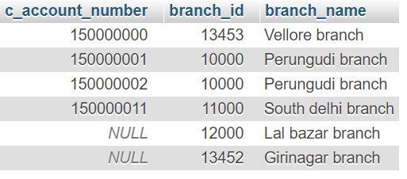

5) Illustration of left join on loan accounts and branch (query looks similar to inner join because all loan accounts mandatory to have branch id)

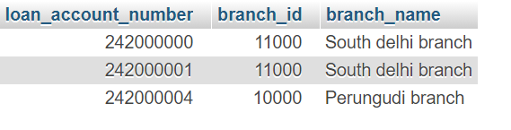

## **5.4 PL/SQL**

**PROCEDURES (3 Questions)**

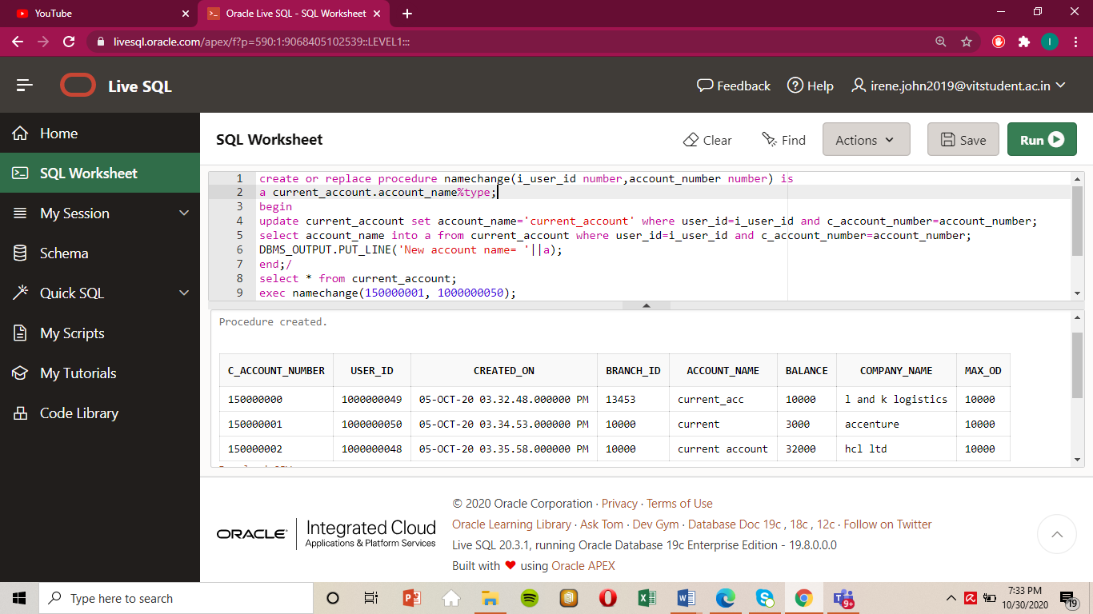Q1.CREATE A PROCEDURE THAT CHANGES THE ACCOUNT NAME TO “CURRENT_ACCOUNT” FOR A PARTICULAR INPUT FOR CURRENT ACCOUNT.

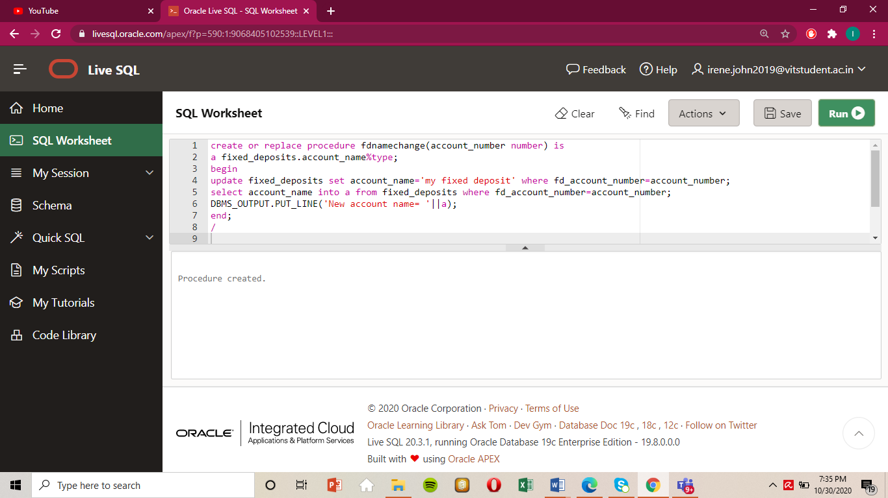Q2.CREATE A PROCEDURE THAT CHANGES THE ACCOUNT NAME TO “my fixed deposit” FOR A PARTICULAR INPUTfor fixed deposit.

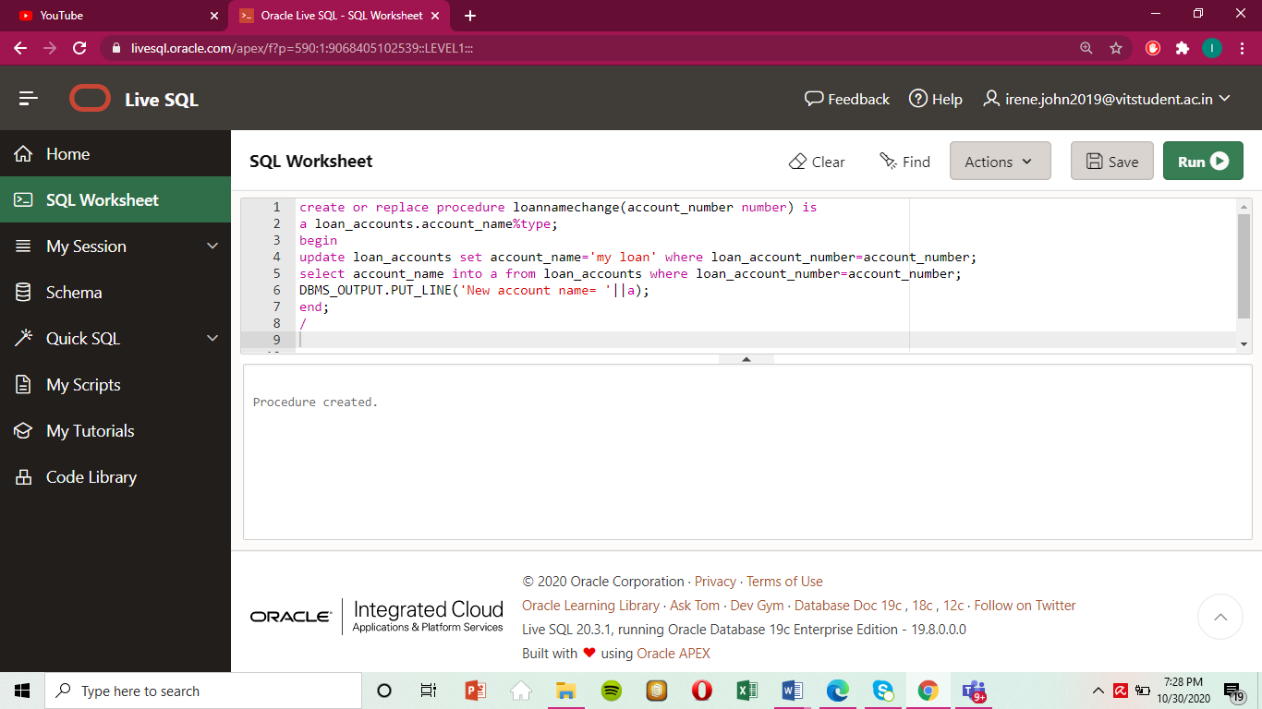Q3: CHANGE ACCOUNT NAME TO “MY_LOAN” IN LOAN_ACCOUNTS.

**FUNCTIONS (3 questions)**

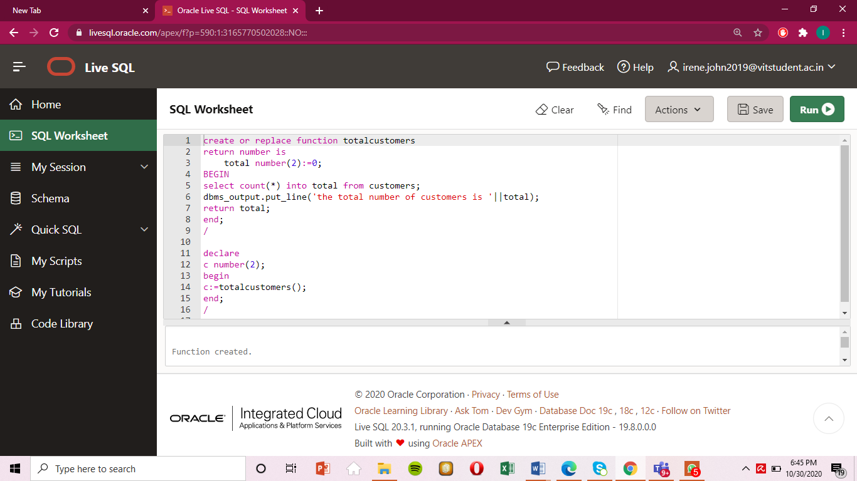Q4.Count the number of customers using a function

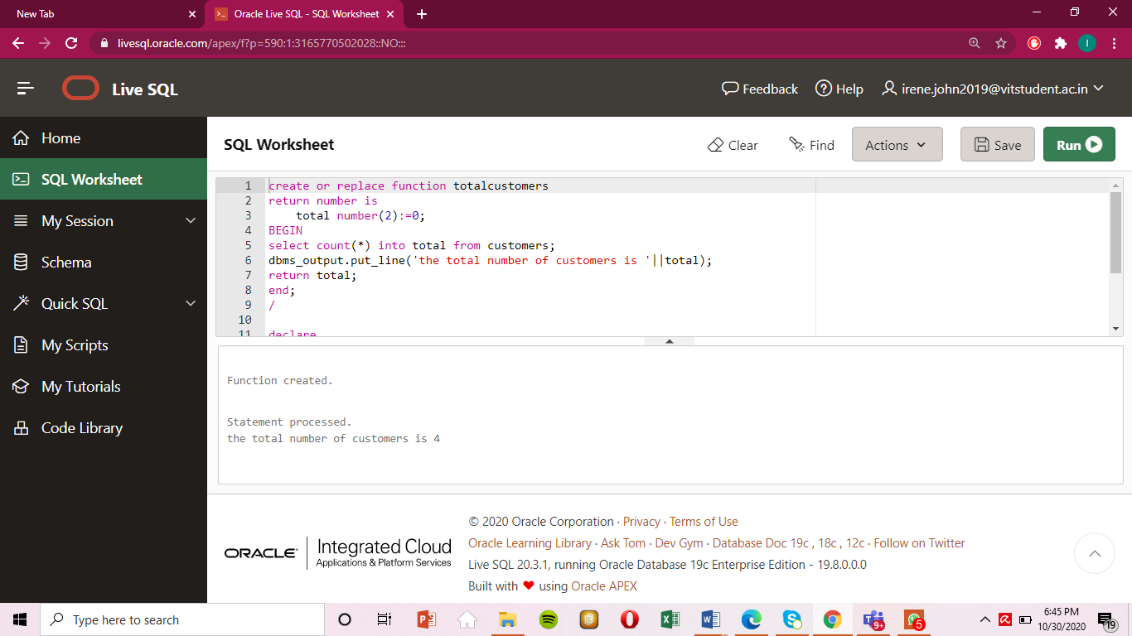

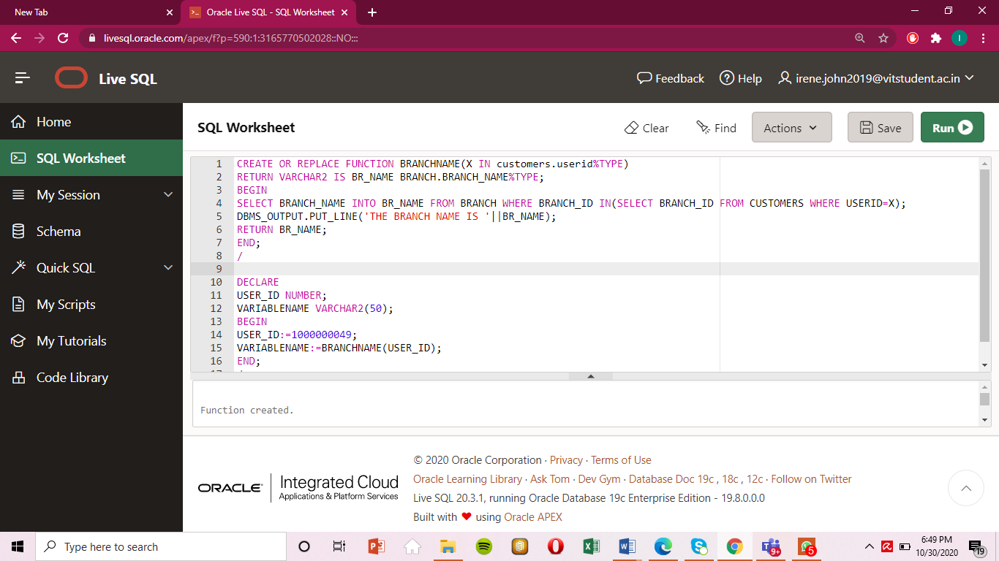Q5.FIND THE BRANCH ID OF A GIVEN USERID AS INPUT USING A FUNCTION.(USE SUBQUERY TO SELECT)

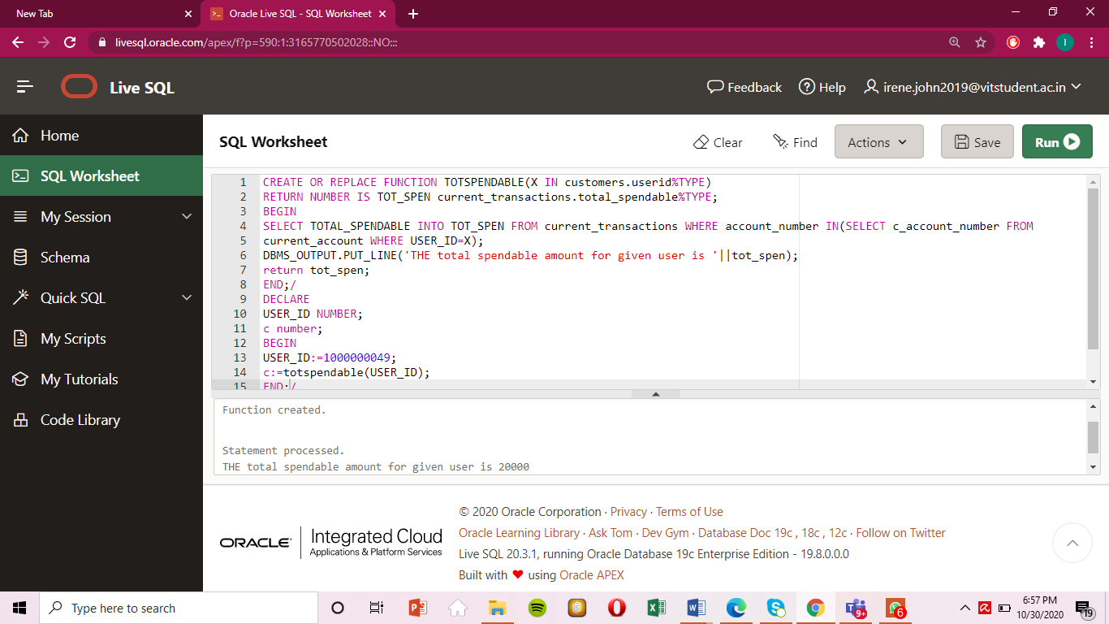Q6.SHOW THE TOTALSPENDABLE AMOUNT FOR A PARTICULAR USERID WHO HAS A CURRENT ACCOUNT.

**CURSORS (1-implicit;1-explicit total= 2 questions)**

**Implicit**

Q7:USE IMPLICIT CURSORS TO CHANGE ALL PASSWORDS FOR CUSTOMERS TO ABCD AND ALSO DISPLAY THE NUMBER OF ROWS AFFECTED.

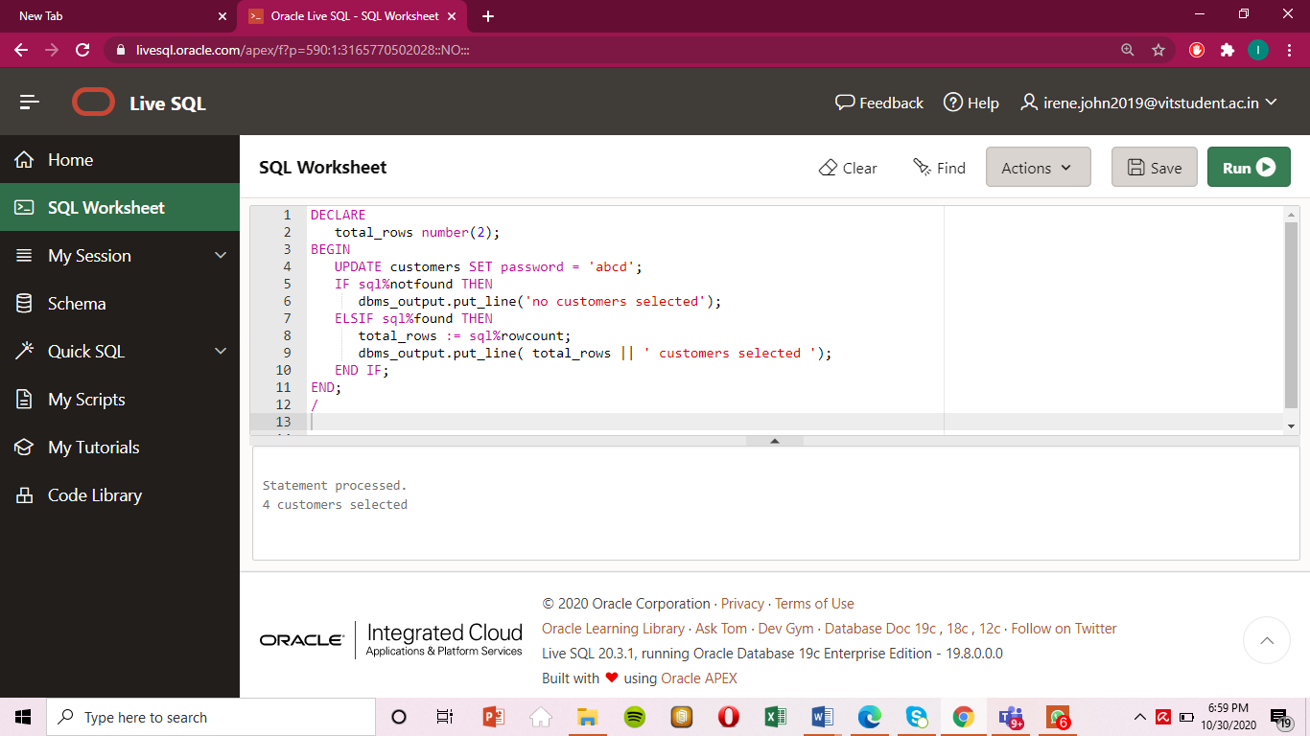

**Explicit**

Q8.DISPLAY CUSTOMER MAIL,NAME AND USERID USING CURSORS

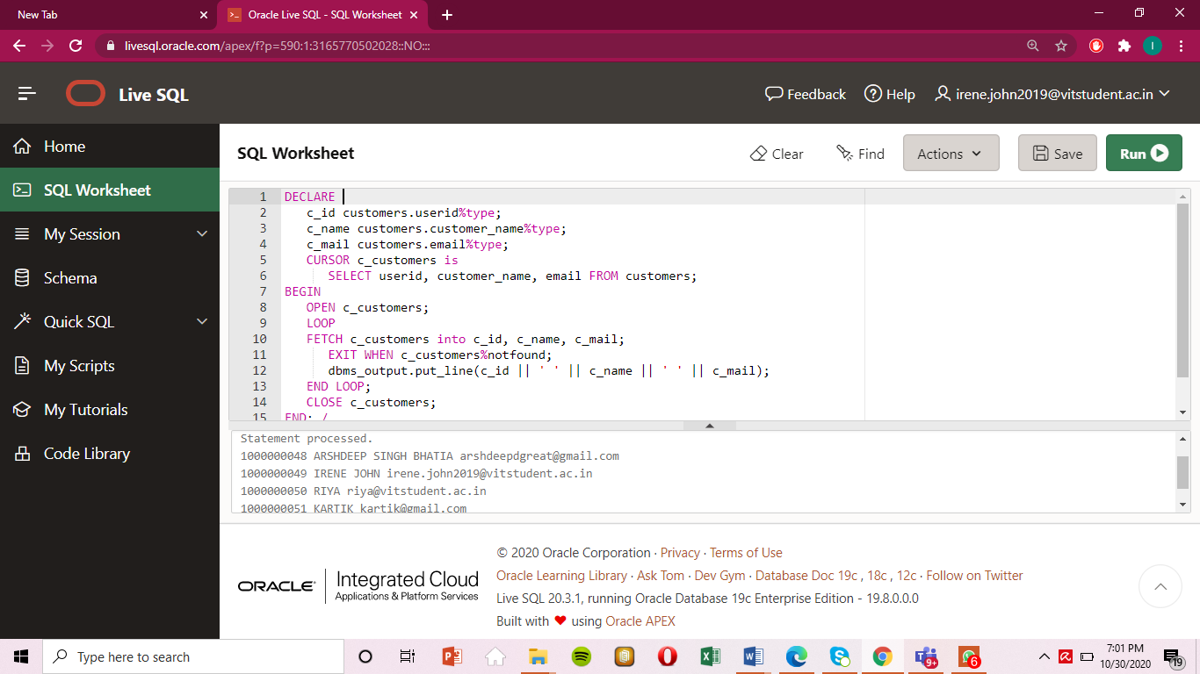

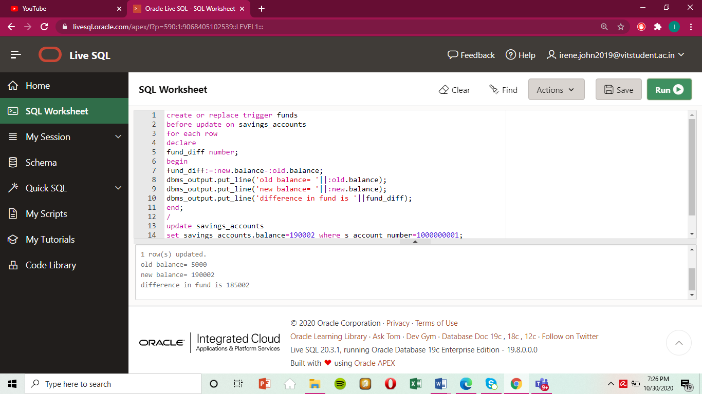**TRIGGERS (2 questions)**

Q9.CREATE A TRIGGER THAT DISPLAYS THE OLD AND NEW PASSWORD WHENEVER A PASSWORD IN CUSTOMER TABLE IS CHANGED.

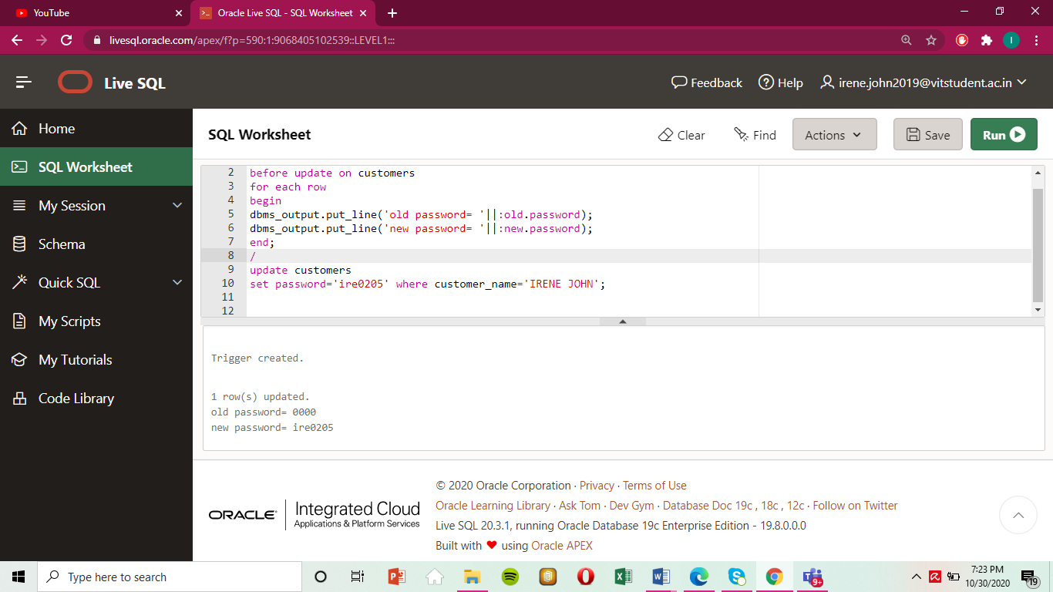Q10.CREATE A TRIGGER THAT DISPLAYS A DIFFERENCE IN THE BALANCE IF A SAVINGS ACCOUNT IS UPDATED

# **6. SCREENSHOTS (FRONT END-WITH EXPLANATION)**

## **6.1 Login screen**

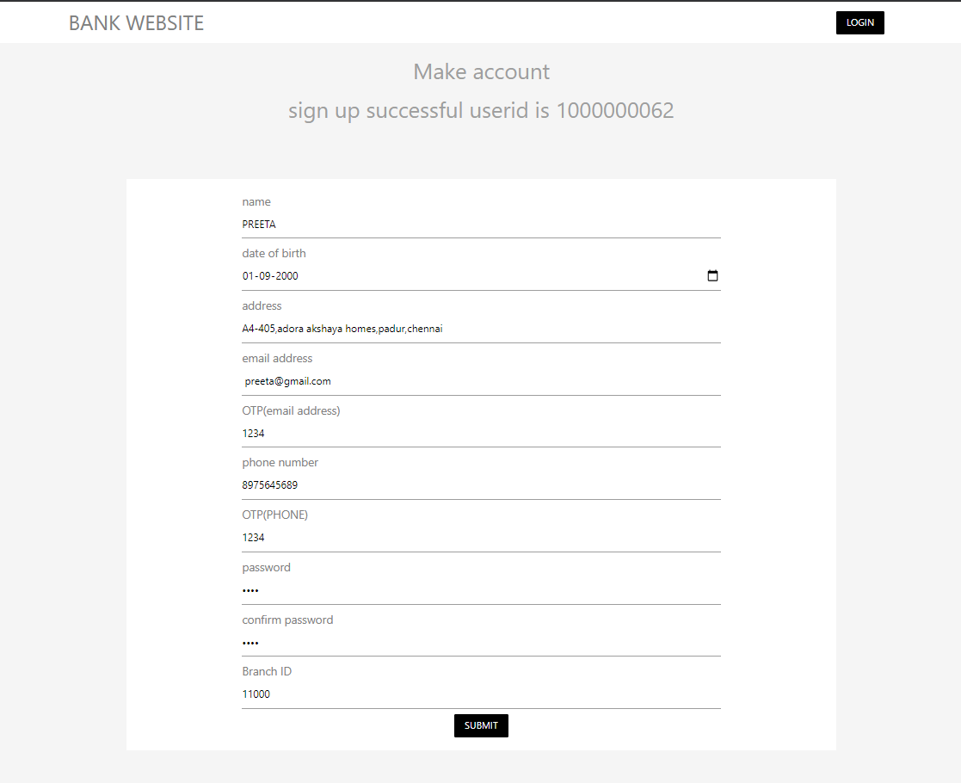

We register as a customer Preeta.

**On successful sign in**

**Accounts view**

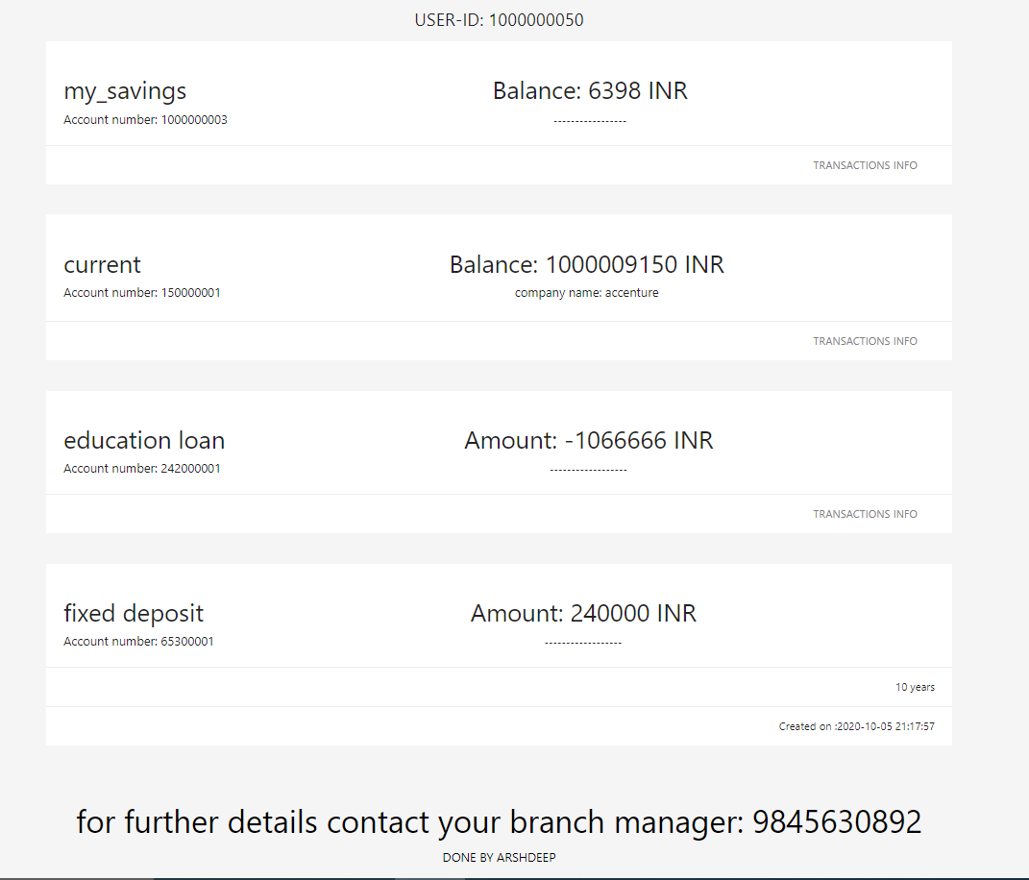

**All transactions read for “my_savings” account**

Displayed values

1. Transaction id
2. Balance after transaction
3. Transaction timestamp
4. Transaction description

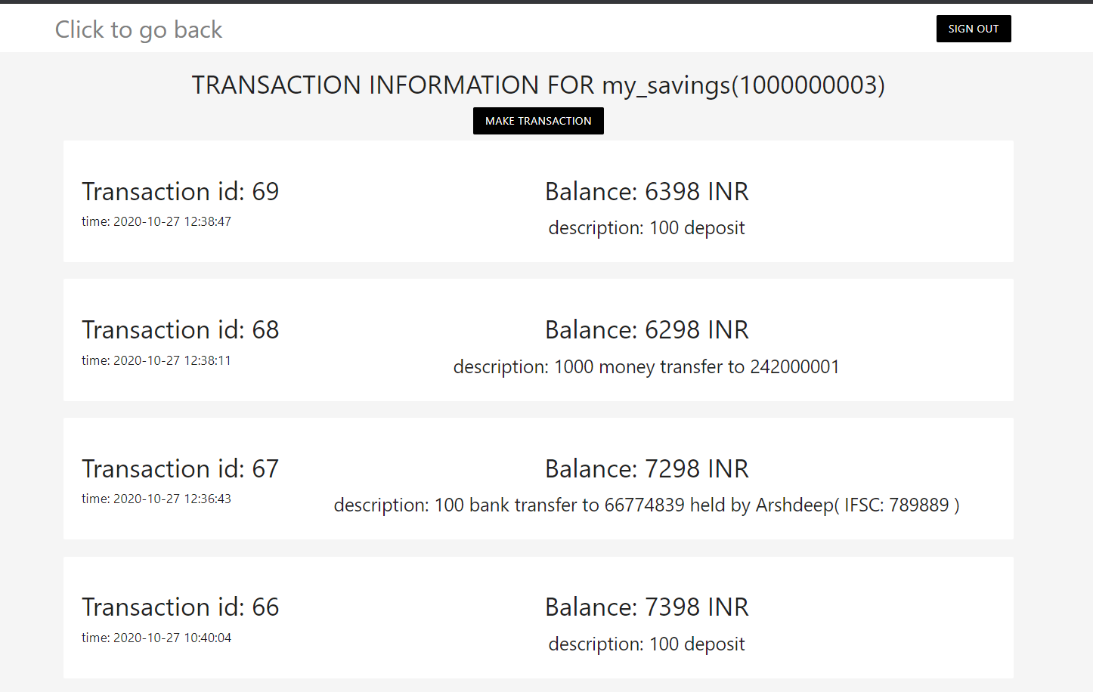

**All transactions read for “current” account**

Displayed values

1. Transaction id
2. Balance after transaction
3. Transaction timestamp
4. Transaction description

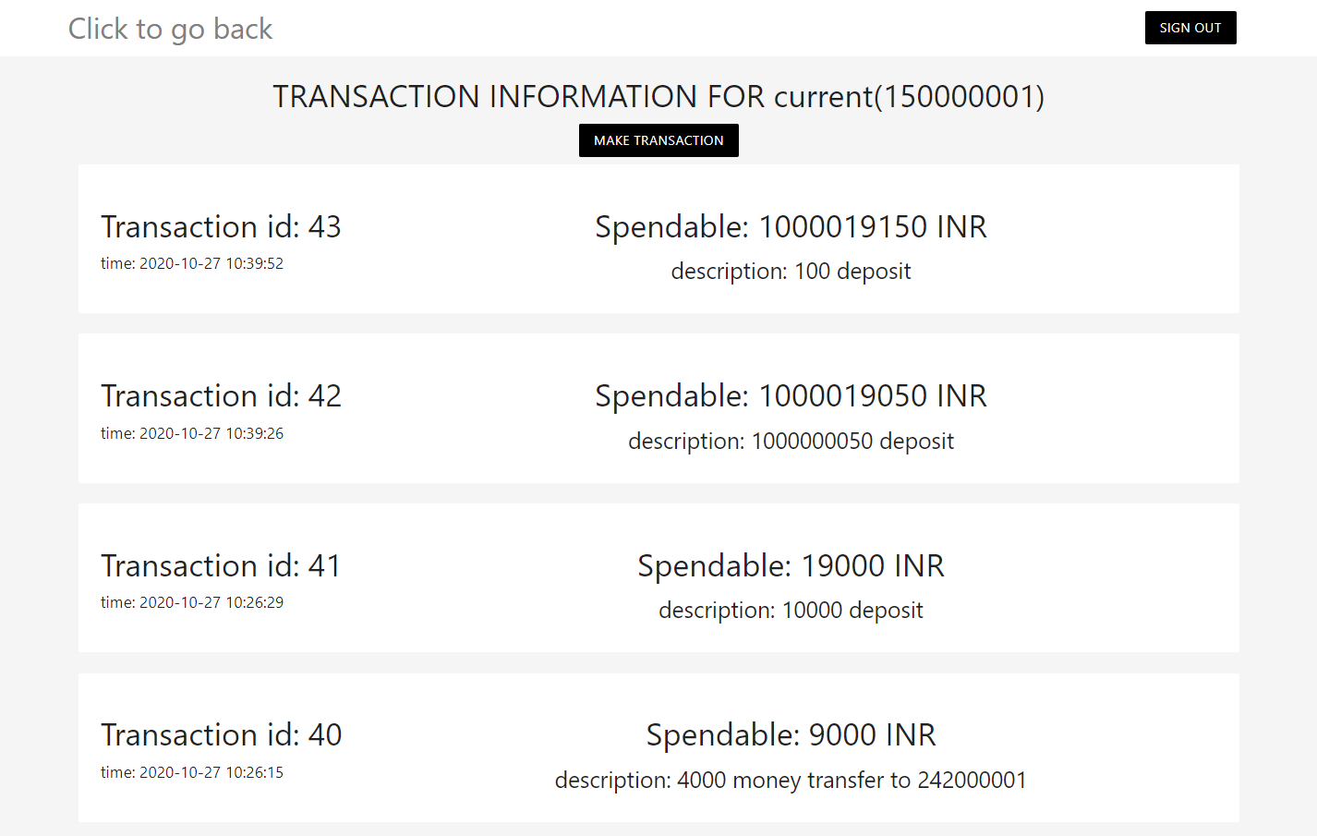

**All payments on loan account**

Displayed values

1. Payment id
2. Remaining Due after transaction
3. Transaction timestamp
4. Amount paid

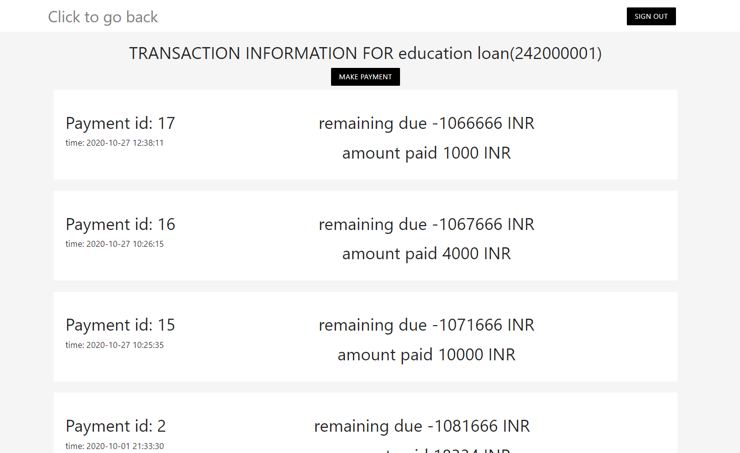

**Fixed Deposits**

1. amount on maturity
2. account number
3. duration of FD
4. creation timestamp

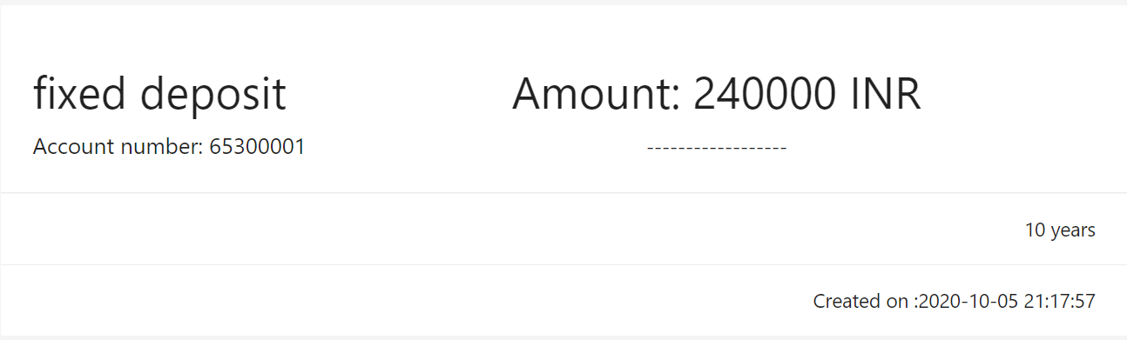

## **6.2 Savings Account creation**

We create a Savings Account.

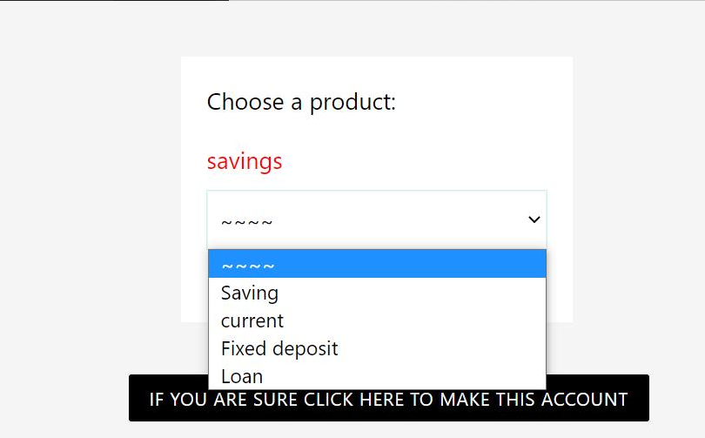

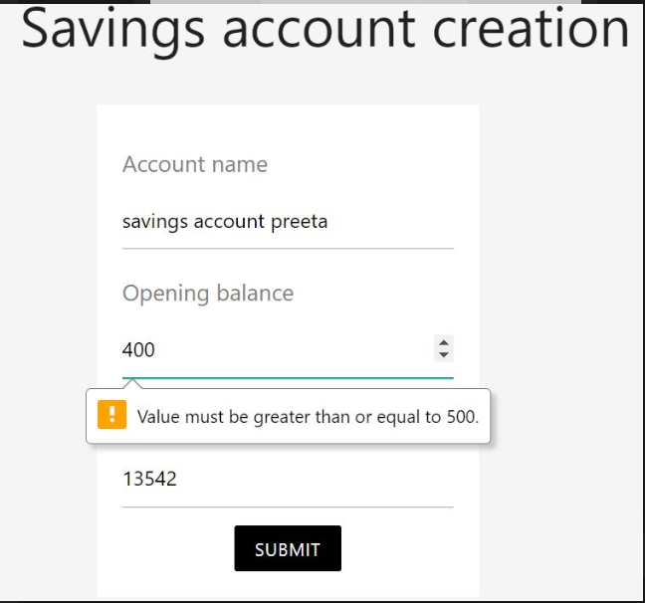

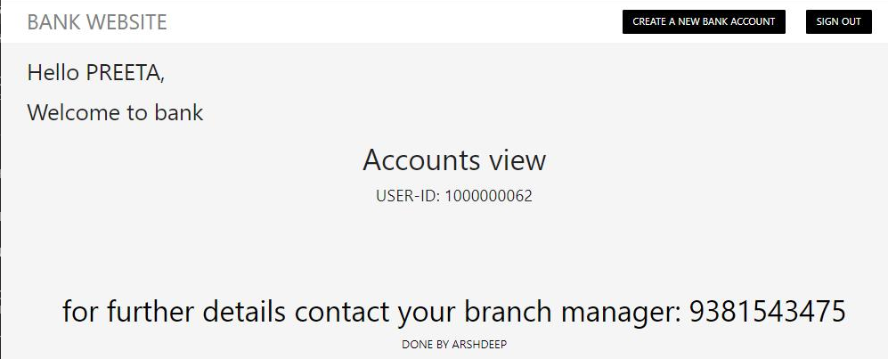

**Before Savings Account Is Created**

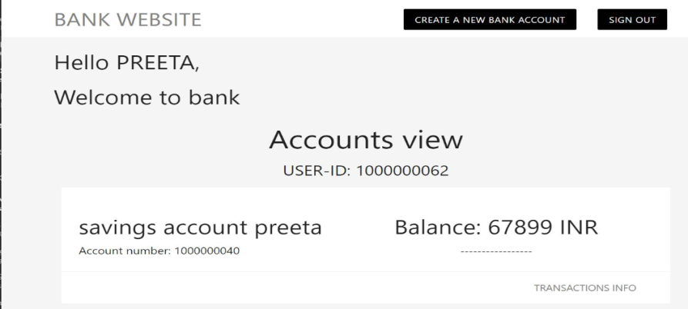

**After Savings Account Is Created**

## **6.3 Transactions**

“Transaction Info” Opens To

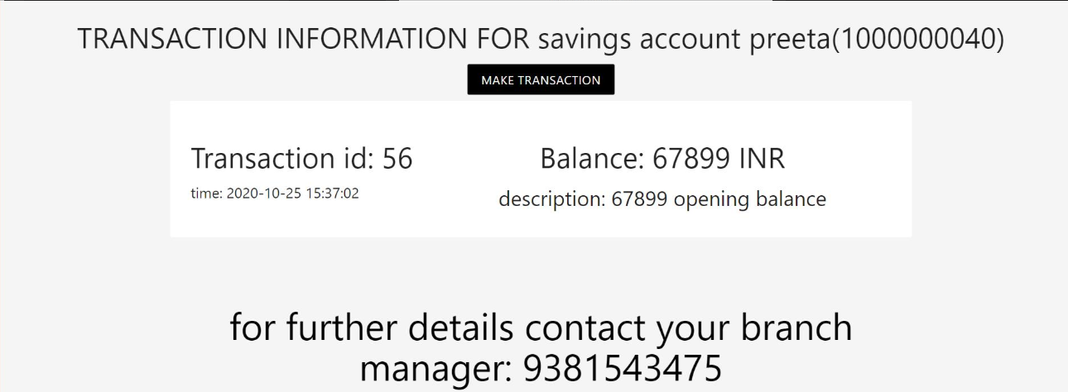

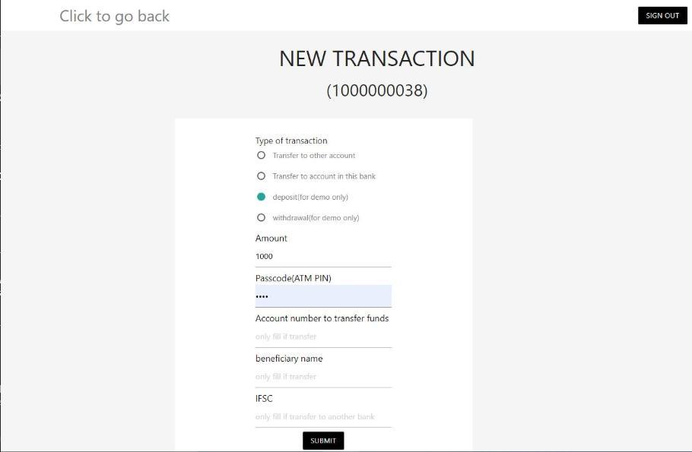

Make Transaction (Refer previous screen shot) opens to…

Here there are 4 different types:

Deposit and Withdrawal works only when the user manually performs it in the bank, Here it is shown for demonstration purpose

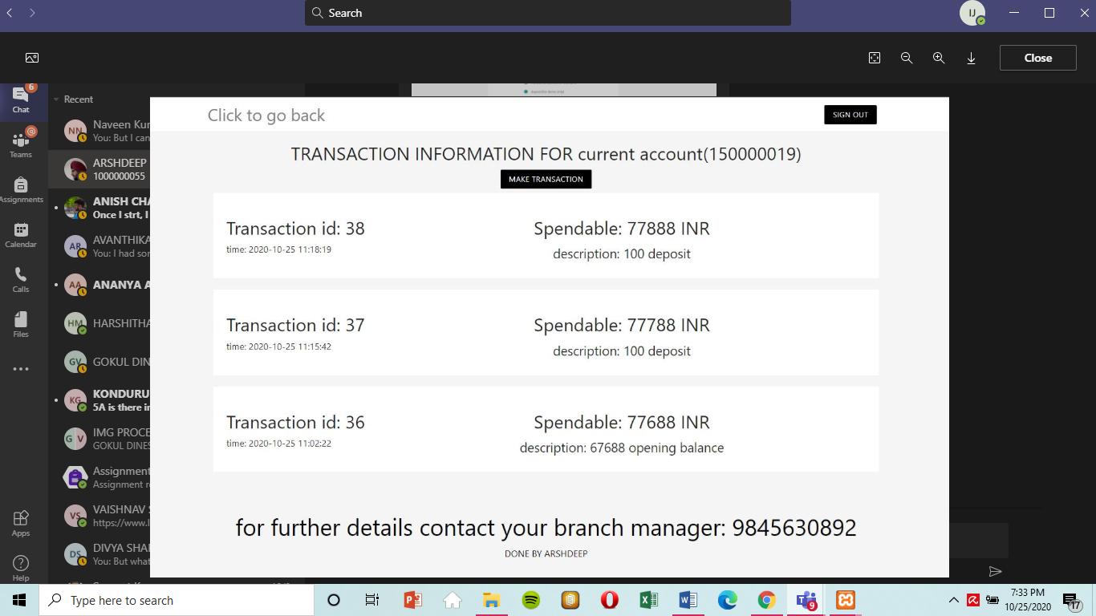Transaction updated in database and frontend

For demonstration purpose we have chosen another account to show multiple transactions made. Here Spendable is shown

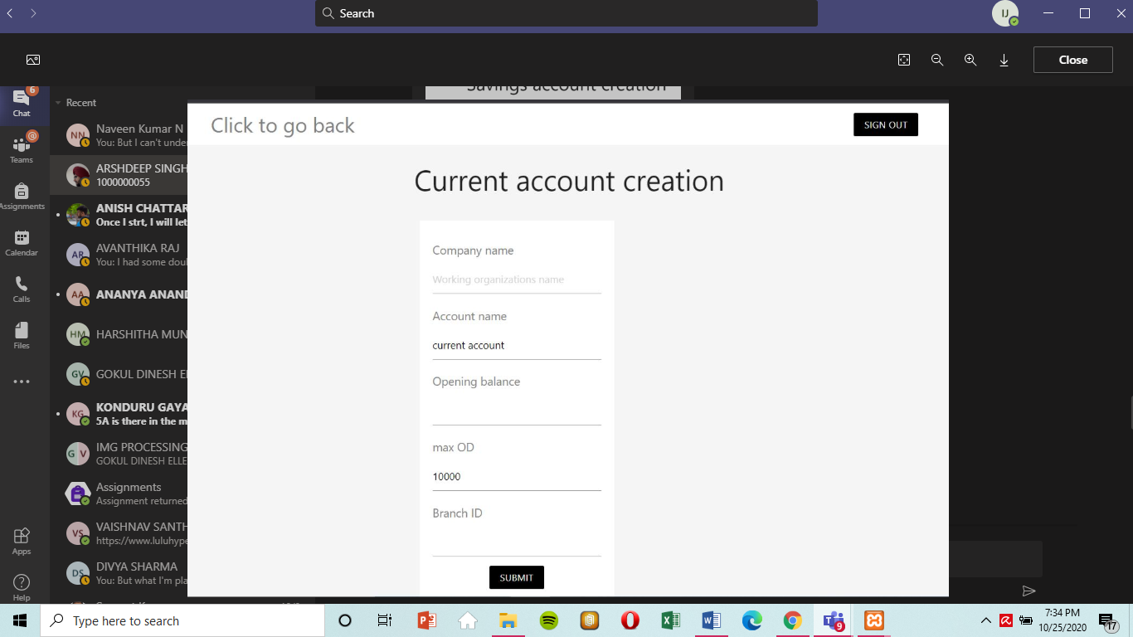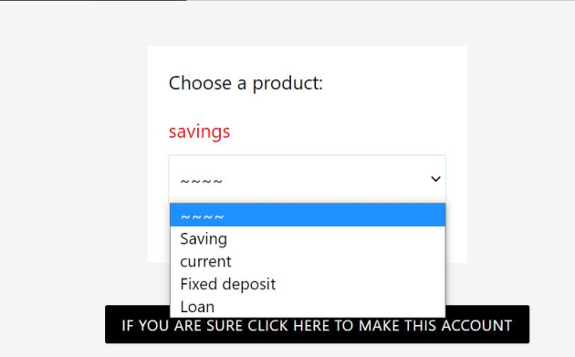

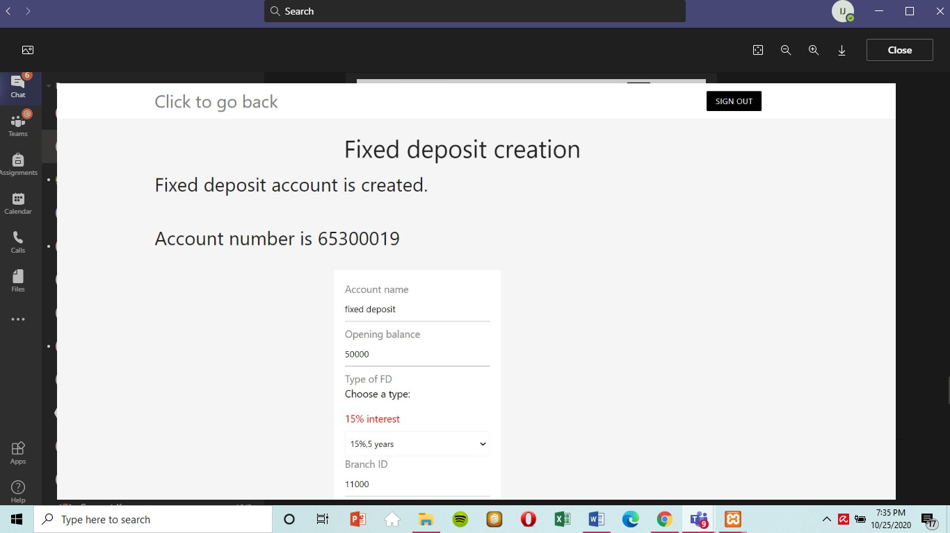

For Fixed Deposit there is no transaction, only opening and closing is present

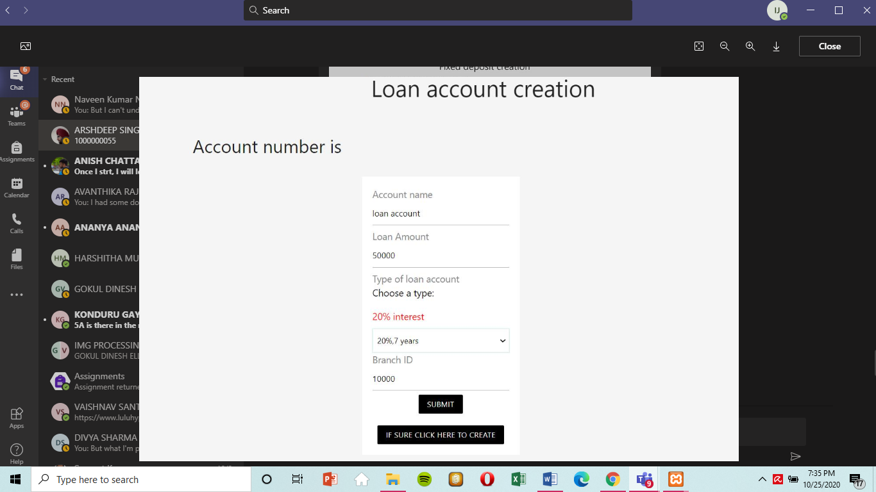

## **Back-end: database view**

1. **Branch table**

**Structure**

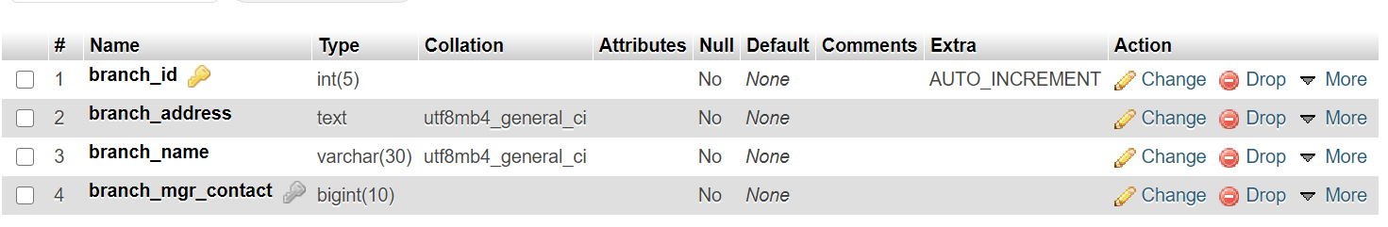

**Snapshot of data**

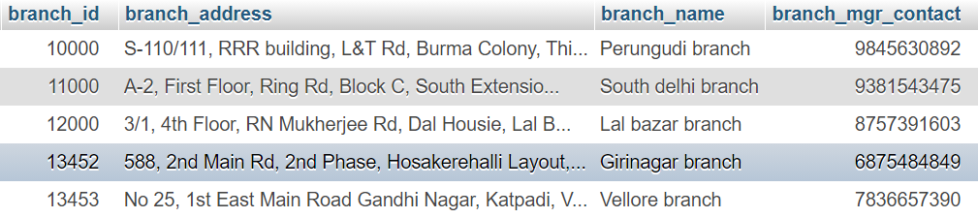

1. **Customers table structure**

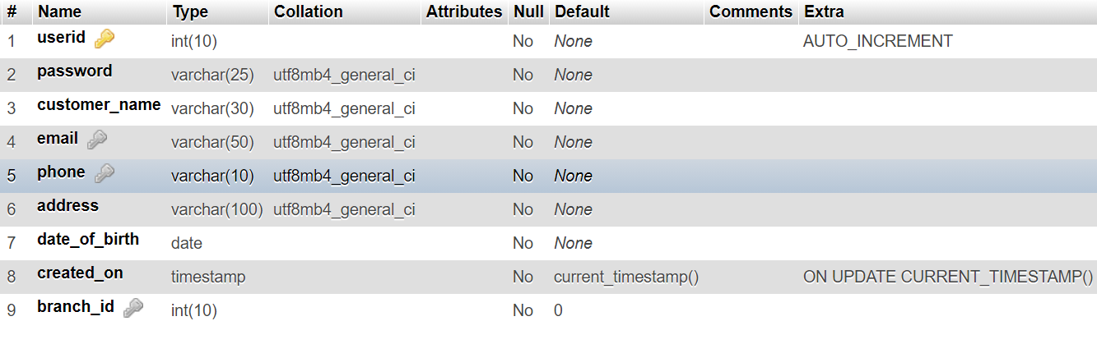

**Foreign key constraints**

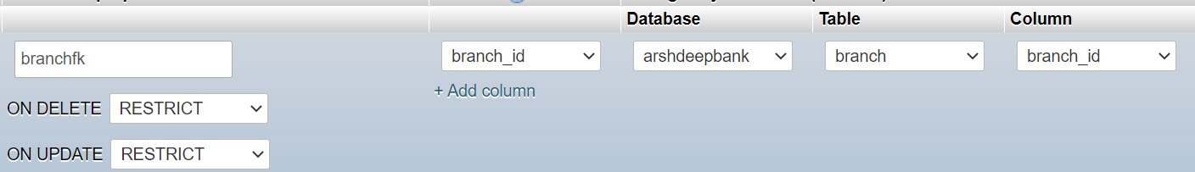

**Snapshot of data**

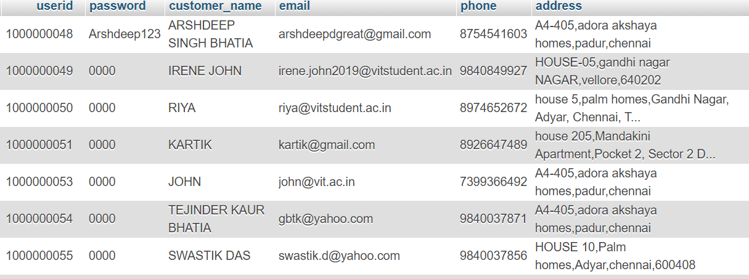

1. **Product master**

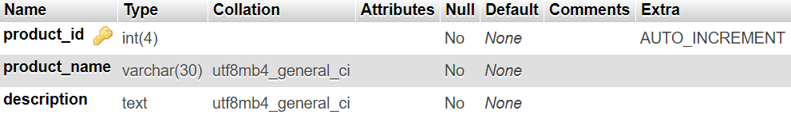

**Data snapshot**

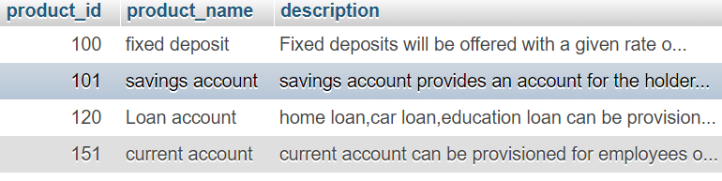

1. 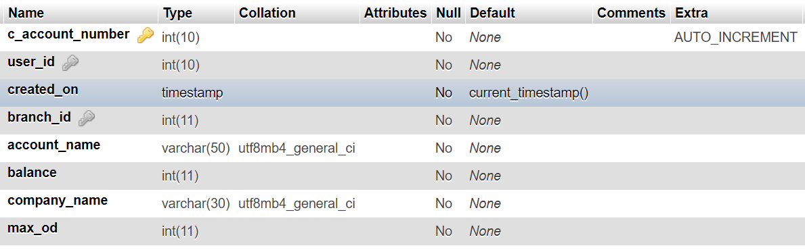**Current accounts**

**Foreign key Constraints**

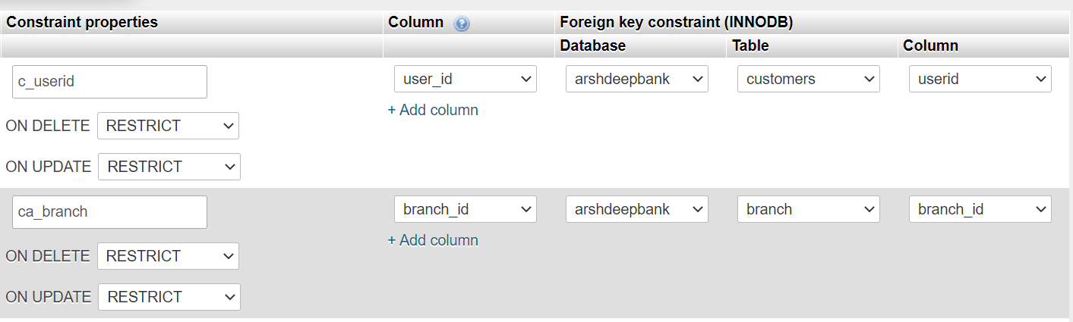

**Data snapshot**

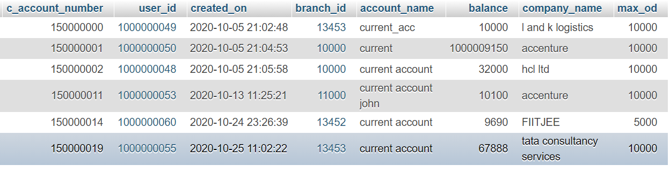

1. **Current transactions**

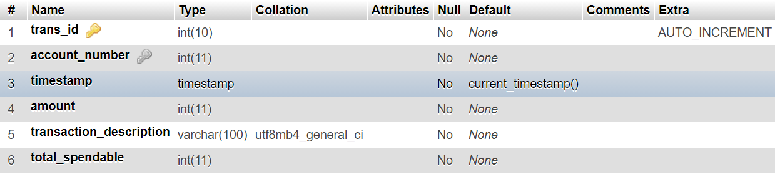

**Constraints**

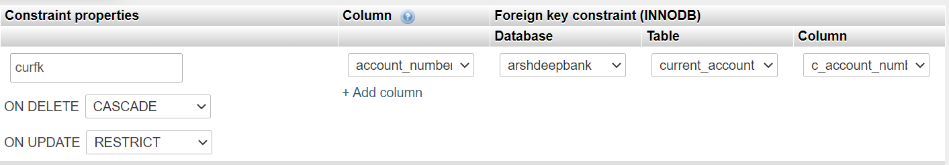

**Snapshot of data**

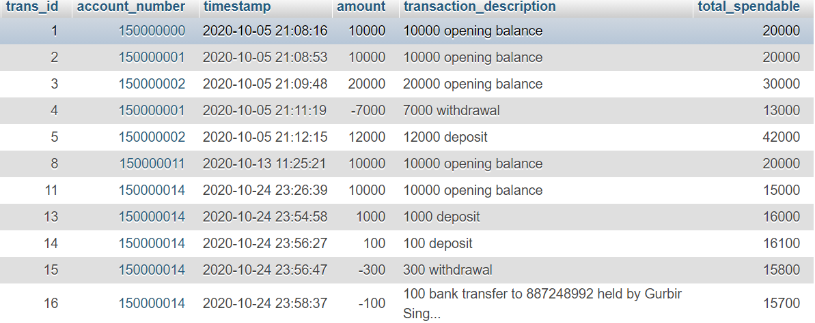

1. **Fixed Deposits**

**Structure**

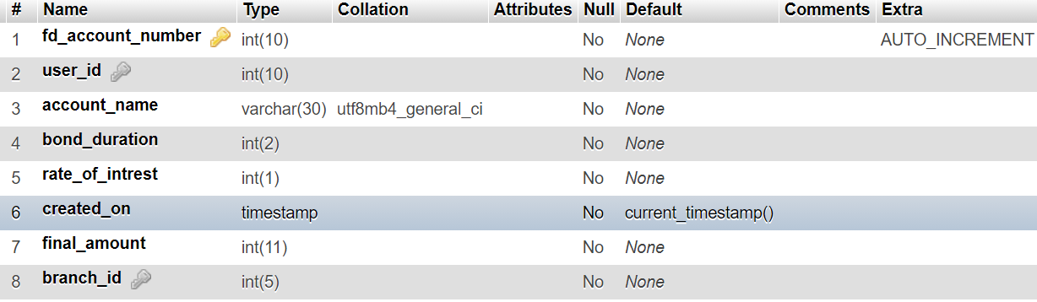

**Foreign keys**

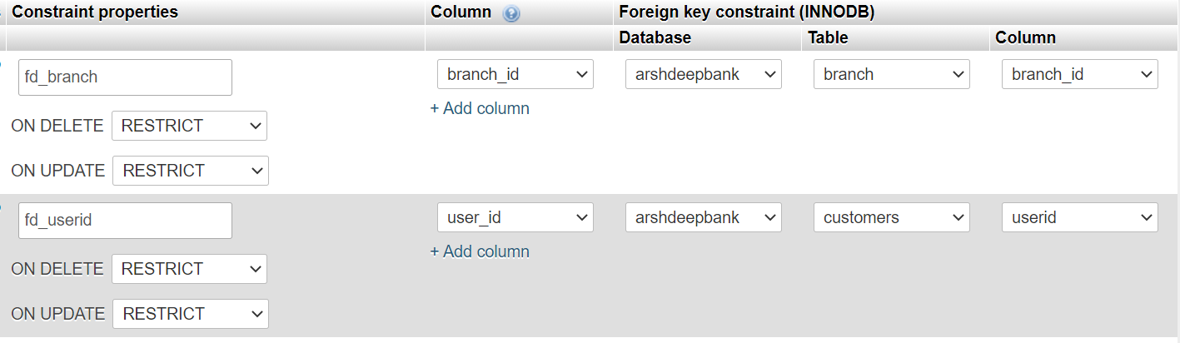

**Snapshot of data**

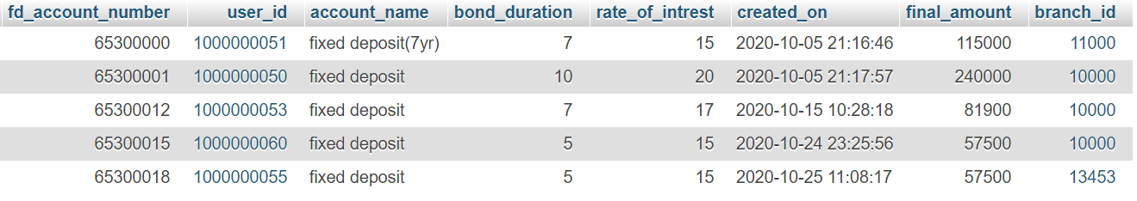

1. **Loan accounts**

**Structure**

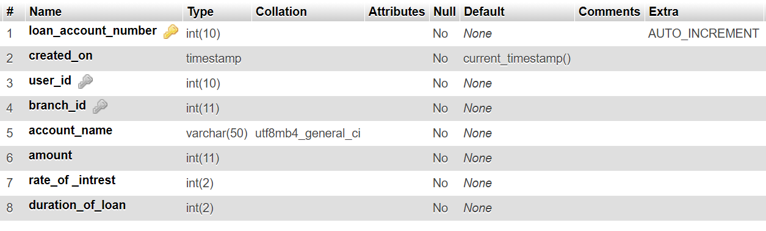

**Foreign key**

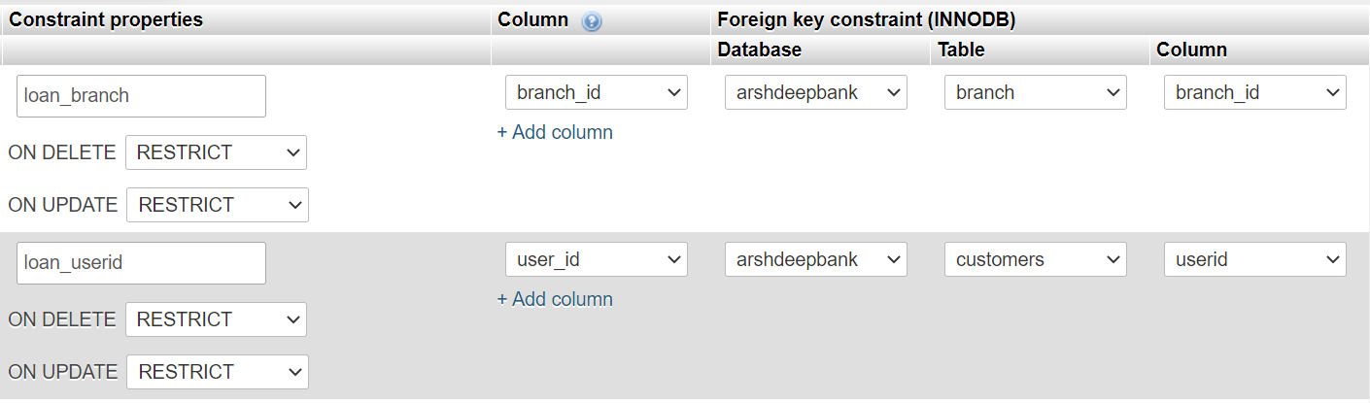

**Snapshot of data**

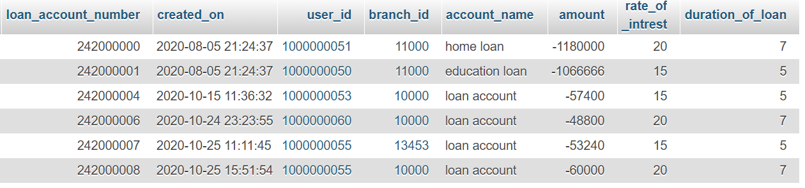

1. **Loan Payments**

**Structure**

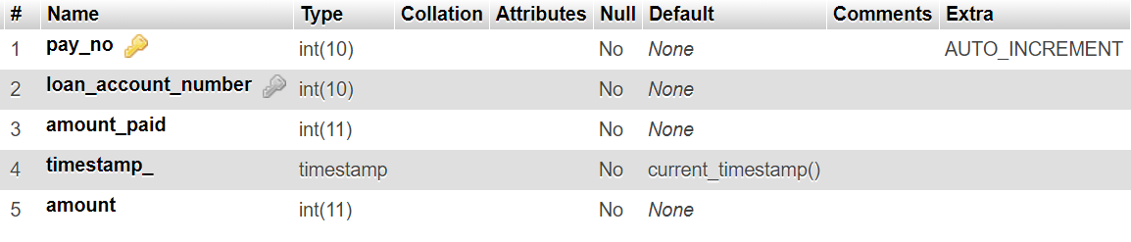

**Foreign key**

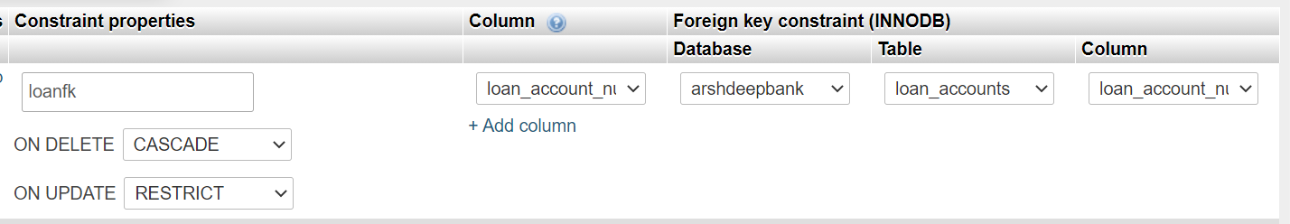

**Snapshot of data**

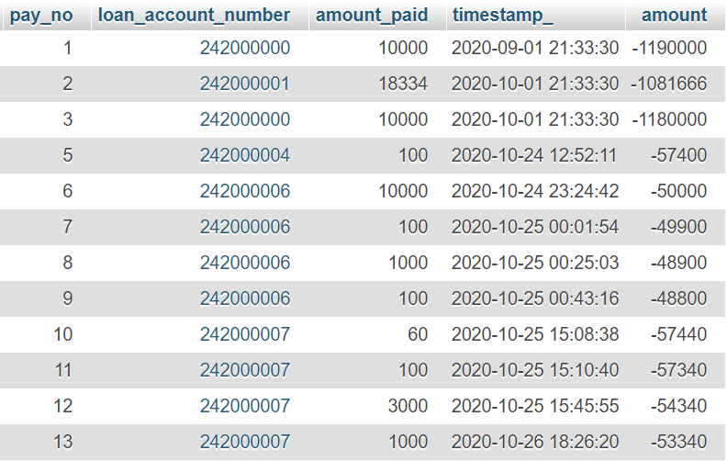

1. **Savings Accounts**

**Structure**

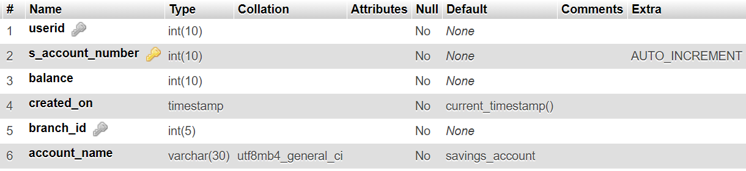

**Foreign keys**

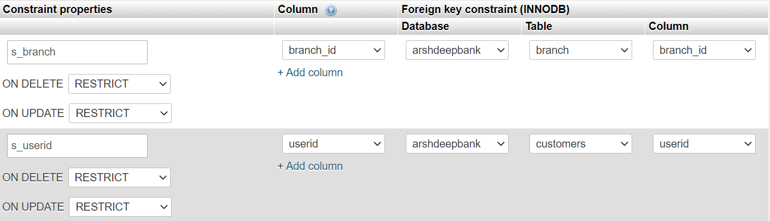

**Snapshot of data**

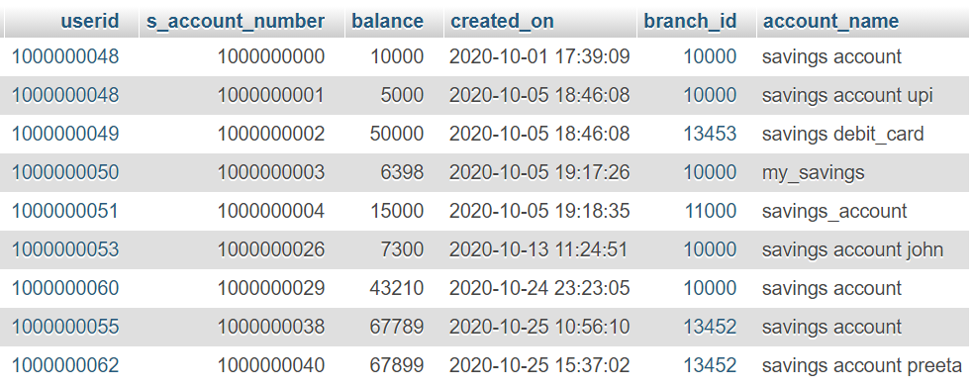

1. **Savings Transactions**

**Structure**

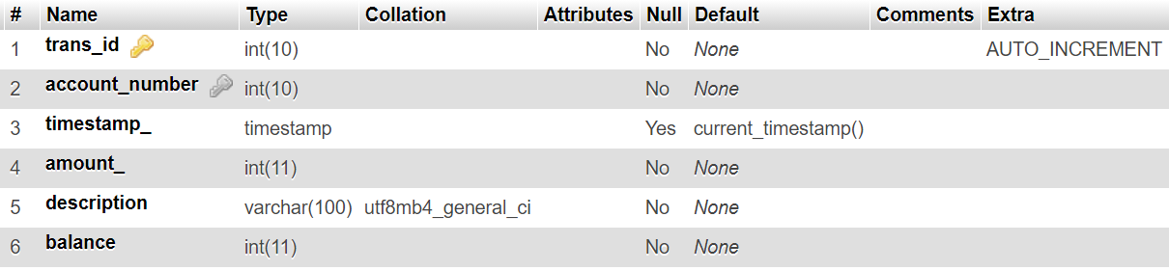

**Foreign keys**

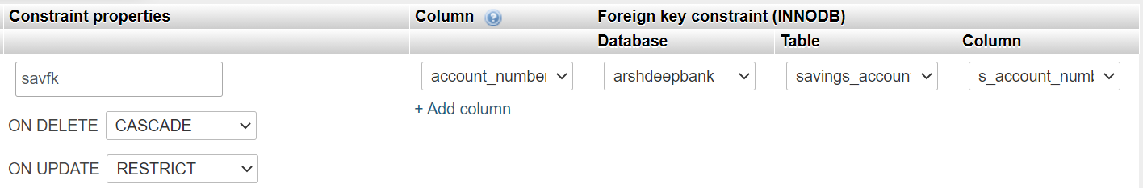

**Snapshot of data**

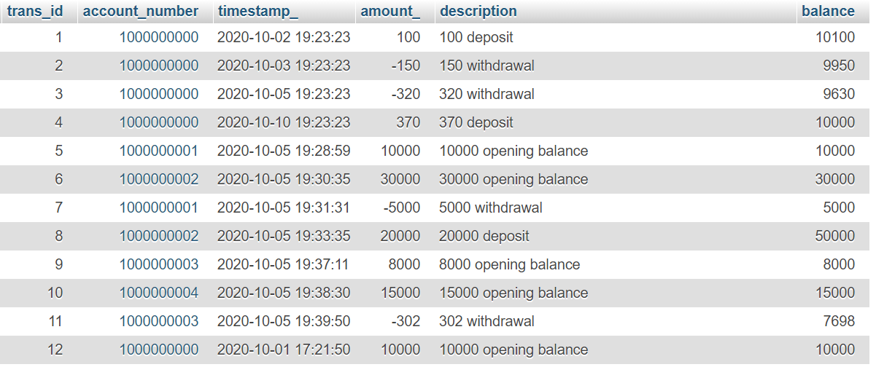

# **7. CONCLUSION AND FUTURE WORK**

## **7.1 Conclusion**

Thus, we successfully created a Banking Management System and created a website by making use of Html, CSS, PHP, MYSQL in XAMMP SERVER, SQL. We also normalized our database in order to maintain consistency in our database. We also created Registration and Login system using PHP and connected that to our database to check the user’s activity in real time. We also added trigger to, MYSQL in XAMMP SERVER database which will be used to store an activity such as insertion, updating, and other functions. Online banking is an innovative tool that is fast becoming a necessity. It is a successful strategic weapon for banks to remain profitable in a volatile and competitive marketplace of today. If proper training should be given to customer by the bank employs to open an account will be beneficial secondly the website should be made friendlier from where the first time customers can directly make and access their accounts.

## **7.2 Future Work**

In order to improve our website further we will add Google API services to make the sign in with Google option enable so that login system can become faster. Also, also add Mailing system to this project using Node Mailer module of NodeJS. We can also deal through internet by creating web pages and a banking website for internet dealing. To attract Account Holder’s we can offer various offers during festivals months. We can also deal in various types of Banking Transactions .To have more and more customer satisfaction we will emphasize more and more on our dealings.

# **REFERENCES:**

[1] C. J. Date, A. Kannan and S. Swamynathan, An Introduction to Database Systems, Pearson Education, Eighth Edition, 2009.

[2] Abraham Silberschatz, Henry F. Korth and S. Sudarshan, Database System Concepts, McGraw-Hill Education (Asia), Fifth Edition, 2006.

[3] Shio Kumar Singh, Database Systems Concepts, Designs and Application, Pearson Education, Second Edition, 2011

[4] Matthew MacDonald, "Creating a Website - The Missing Manual", 3rd ed, 2011, O’Reilly. (A good introductory book on HTML/CSS. A new version is expected in July 2015.)

[5] PHP documentation